General Aviation Joint Safety Committee
Loss of Control Working Group

Winter Flying Tips
2024/09-10-316(I)PP

This outreach guidance is provided to all FAA and aviation industry groups that are participating in outreach efforts sponsored by the General Aviation Joint Safety Committee (GAJSC). It is important that all outreach on a given topic is coordinated and is free of conflicts. Therefore, all outreach products should be in alignment with the outline and concepts listed below for this topic.

Outreach Month: December 2026

Topic: Winter Flying Tips (SE 34 Output)
The FAA and industry will conduct a public education campaign emphasizing the hazards associated with General Aviation Flight Operations in winter.

Background:

Winter flying can feature clear skys and great visibility but it can also bring hazardous weather conditions in the air and on the ground. Pilots are encouraged to learn how to prepare for and execute safe winter flight operations.

Teaching Points:
- Preflight tasks and even the commute to the airport can take longer in winter so pilots are encouraged to allow extra time before and after each flight.
- Forced landings in snow often feature fewer and less severe injuries but survival on the ground depends on having survival knowledge, skill, and equipment.
- Pilots must accurately conduct thorough pre and post flight inspections including the aircraft surfaces are free of snow, ice, and frost contamination.
- Pilots should wear clothing appropriate for outdoor activity in the environment over which they’ll be flying.
- Essential survival gear should be carried on one’s person – not stowed in baggage compartments.

References:
- November/December 2014 FAA Safety Briefing Magazine – Winter Operations
  - https://www.faa.gov/sites/faa.gov/files/2022-01/NovDec2014.pdf
- FAA Winter Flying Tips P-8740-24 Rev 1
  - https://www.faasafety.gov/files/events/GL/GL09/2018/GL0985130/P-8740-24.pdf

Abstract: Lasting 10 to 15 Minutes, this presentation acquaints the audience with the hazards of fliying in winter weather environments and provides suggestions for successful flight and ground operations in winter.

Format: Information Briefing – Power Point presentation

Required Personnel: FAASTeam Program Manager or designated FAASTeam Rep (s)

Optional Personnel: Flight Instructor or others who can speak on CFIT

National FAASTeam Support: In addition to this document, a Power Point presentation that supports the program is provided. FPMs and presentaers are encouraged to customize this presentation to reflect each individual program.

Slides | Script
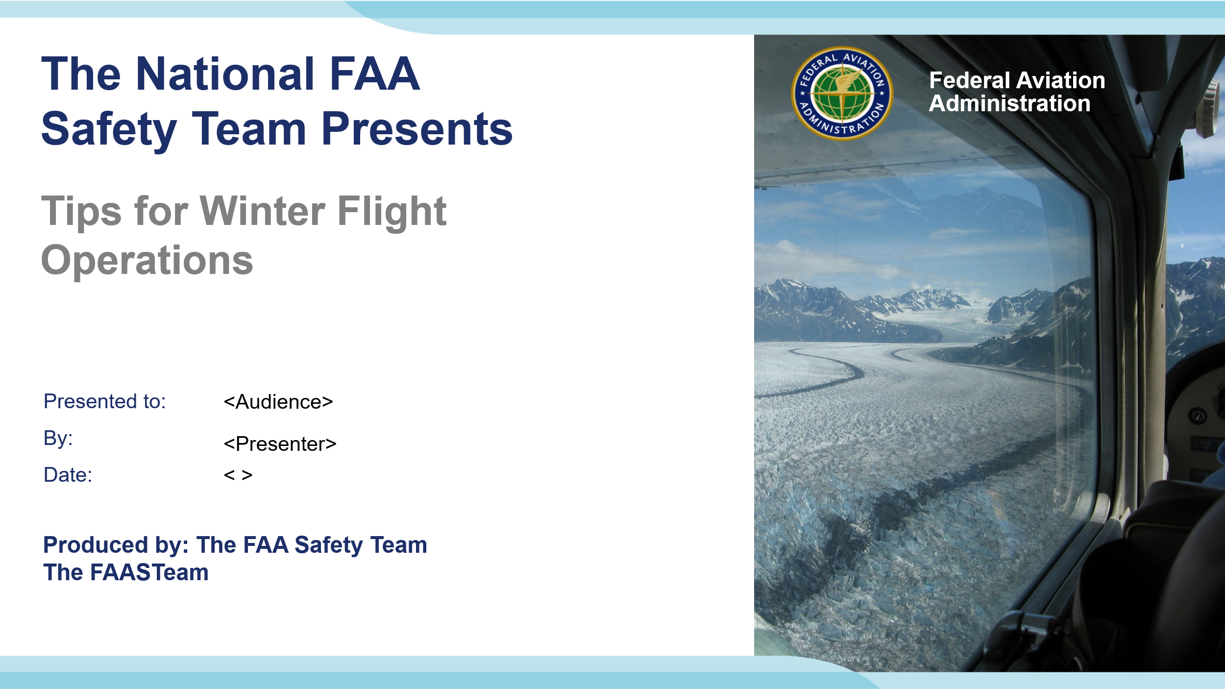 | Slide 1  2024/09-10-316(I)PP Original Author: J. Steuernagle November 2024 - POC: K. Clover National FAASTeam Program Manager (Ops) Office 562-888-2020  Presentation Note: This is the title slide for Tips for Winter Flight Operations  - Script - We have included a script of suggested dialog with most slides. The script will always appear in a non-italic font. Presenters may read the script or modify it to suit their own presentation style. See template slides 5 and 6 for examples of a slides with script.  - Presentation Instructions - (stage direction and presentation suggestions) will be preceded by a Bold header: the instructions themselves will be in Italic fonts. See slides 2, for an example of slides with Presentation Instructions only.  - Program control instructions - will be in bold fonts and look like this: (Click) for building information within a slide; or this: (Next Slide) for slide advance.  - Background information - Some slides may contain background information that supports the concepts presented in the program.  Background information will always appear last and will be preceded by a bold Background: identification.  The production team hope you and your audience will enjoy the show. Break a leg!  (Next Slide)
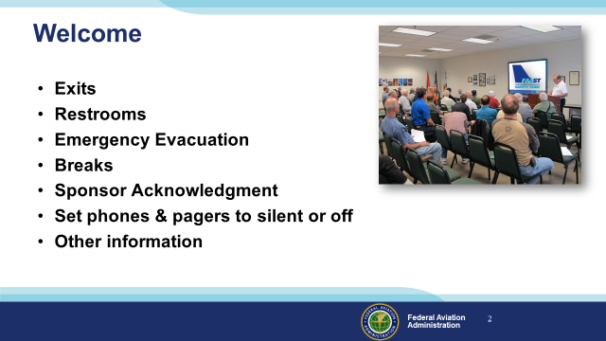 | Slide 2  Presentation Note: Here’s where you can discuss venue logistics, acknowledge sponsors, and deliver other information you want your audience to know in the beginning.  You can add slides after this one to fit your situation (Next Slide)
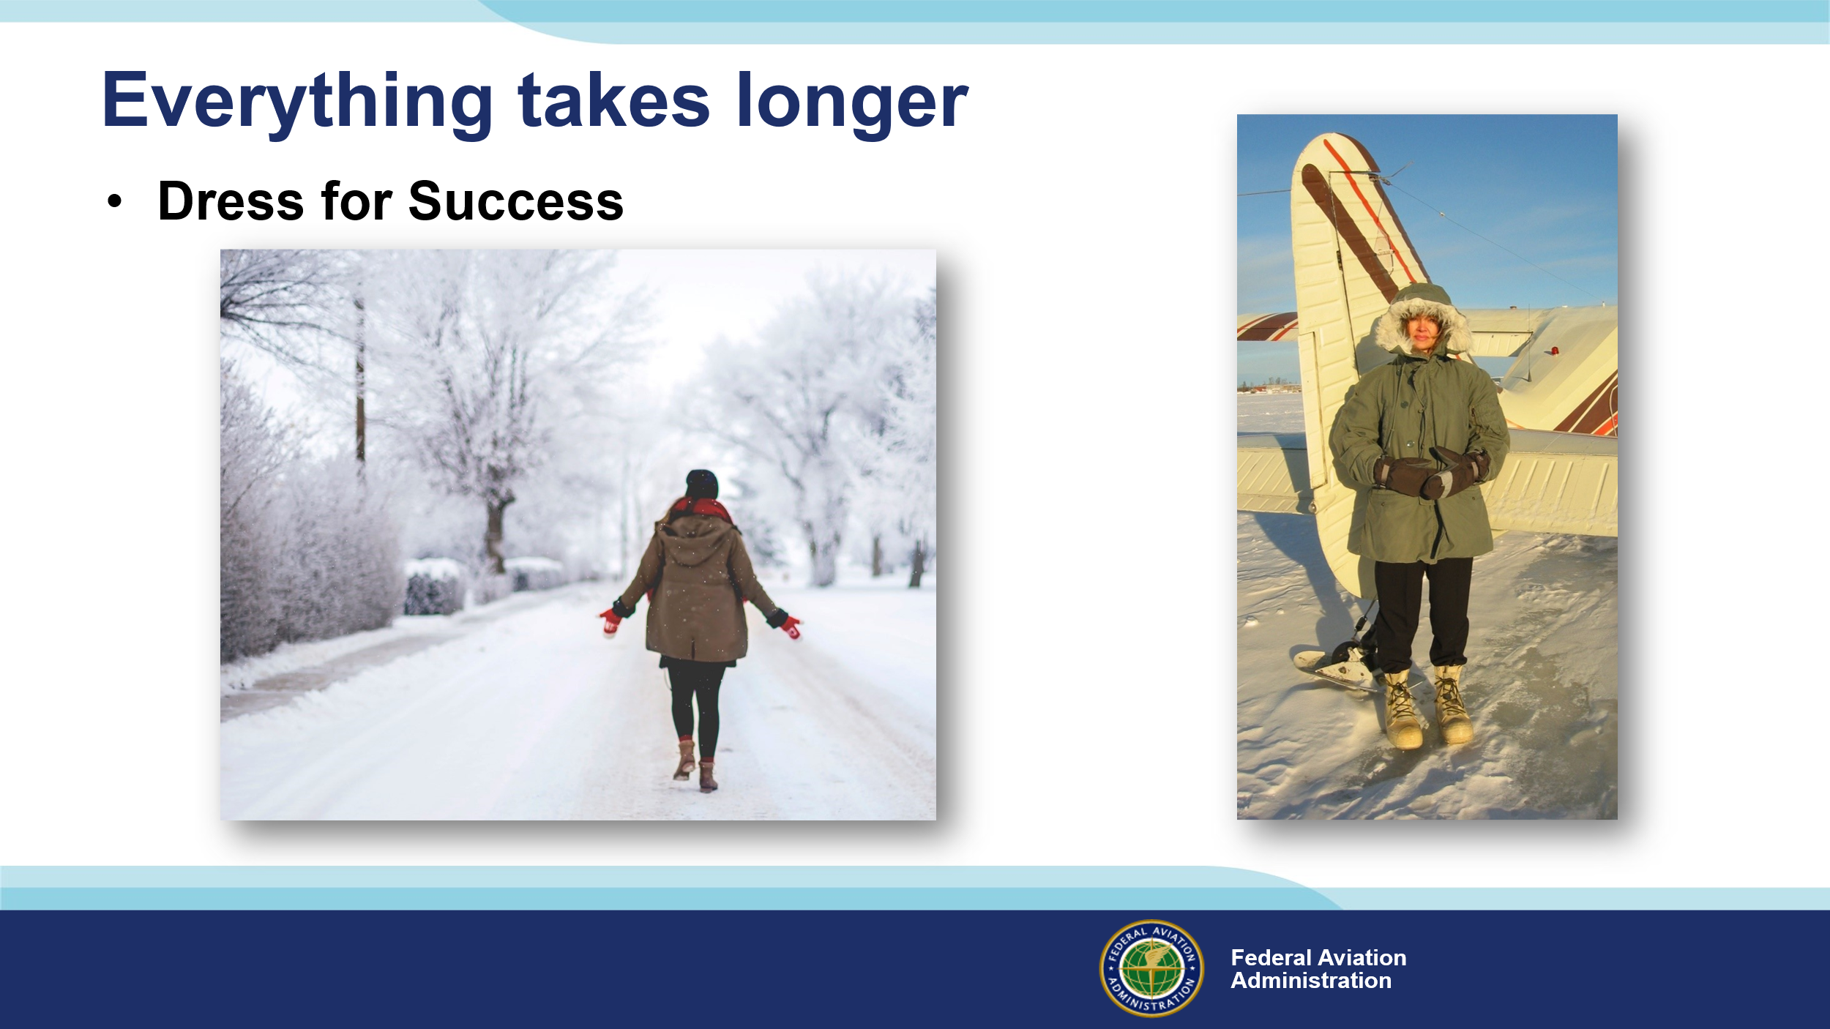 | Slide 3  It seems like everything takes longer in winter. Just getting ready to leave the house involves dressing for the operational environment. Walking a couple of blocks in the city (Click)  is considerably easier than making your way in the boonies. Either way it pays to dress for success. That means wearing protective clothing.  (Next Slide)
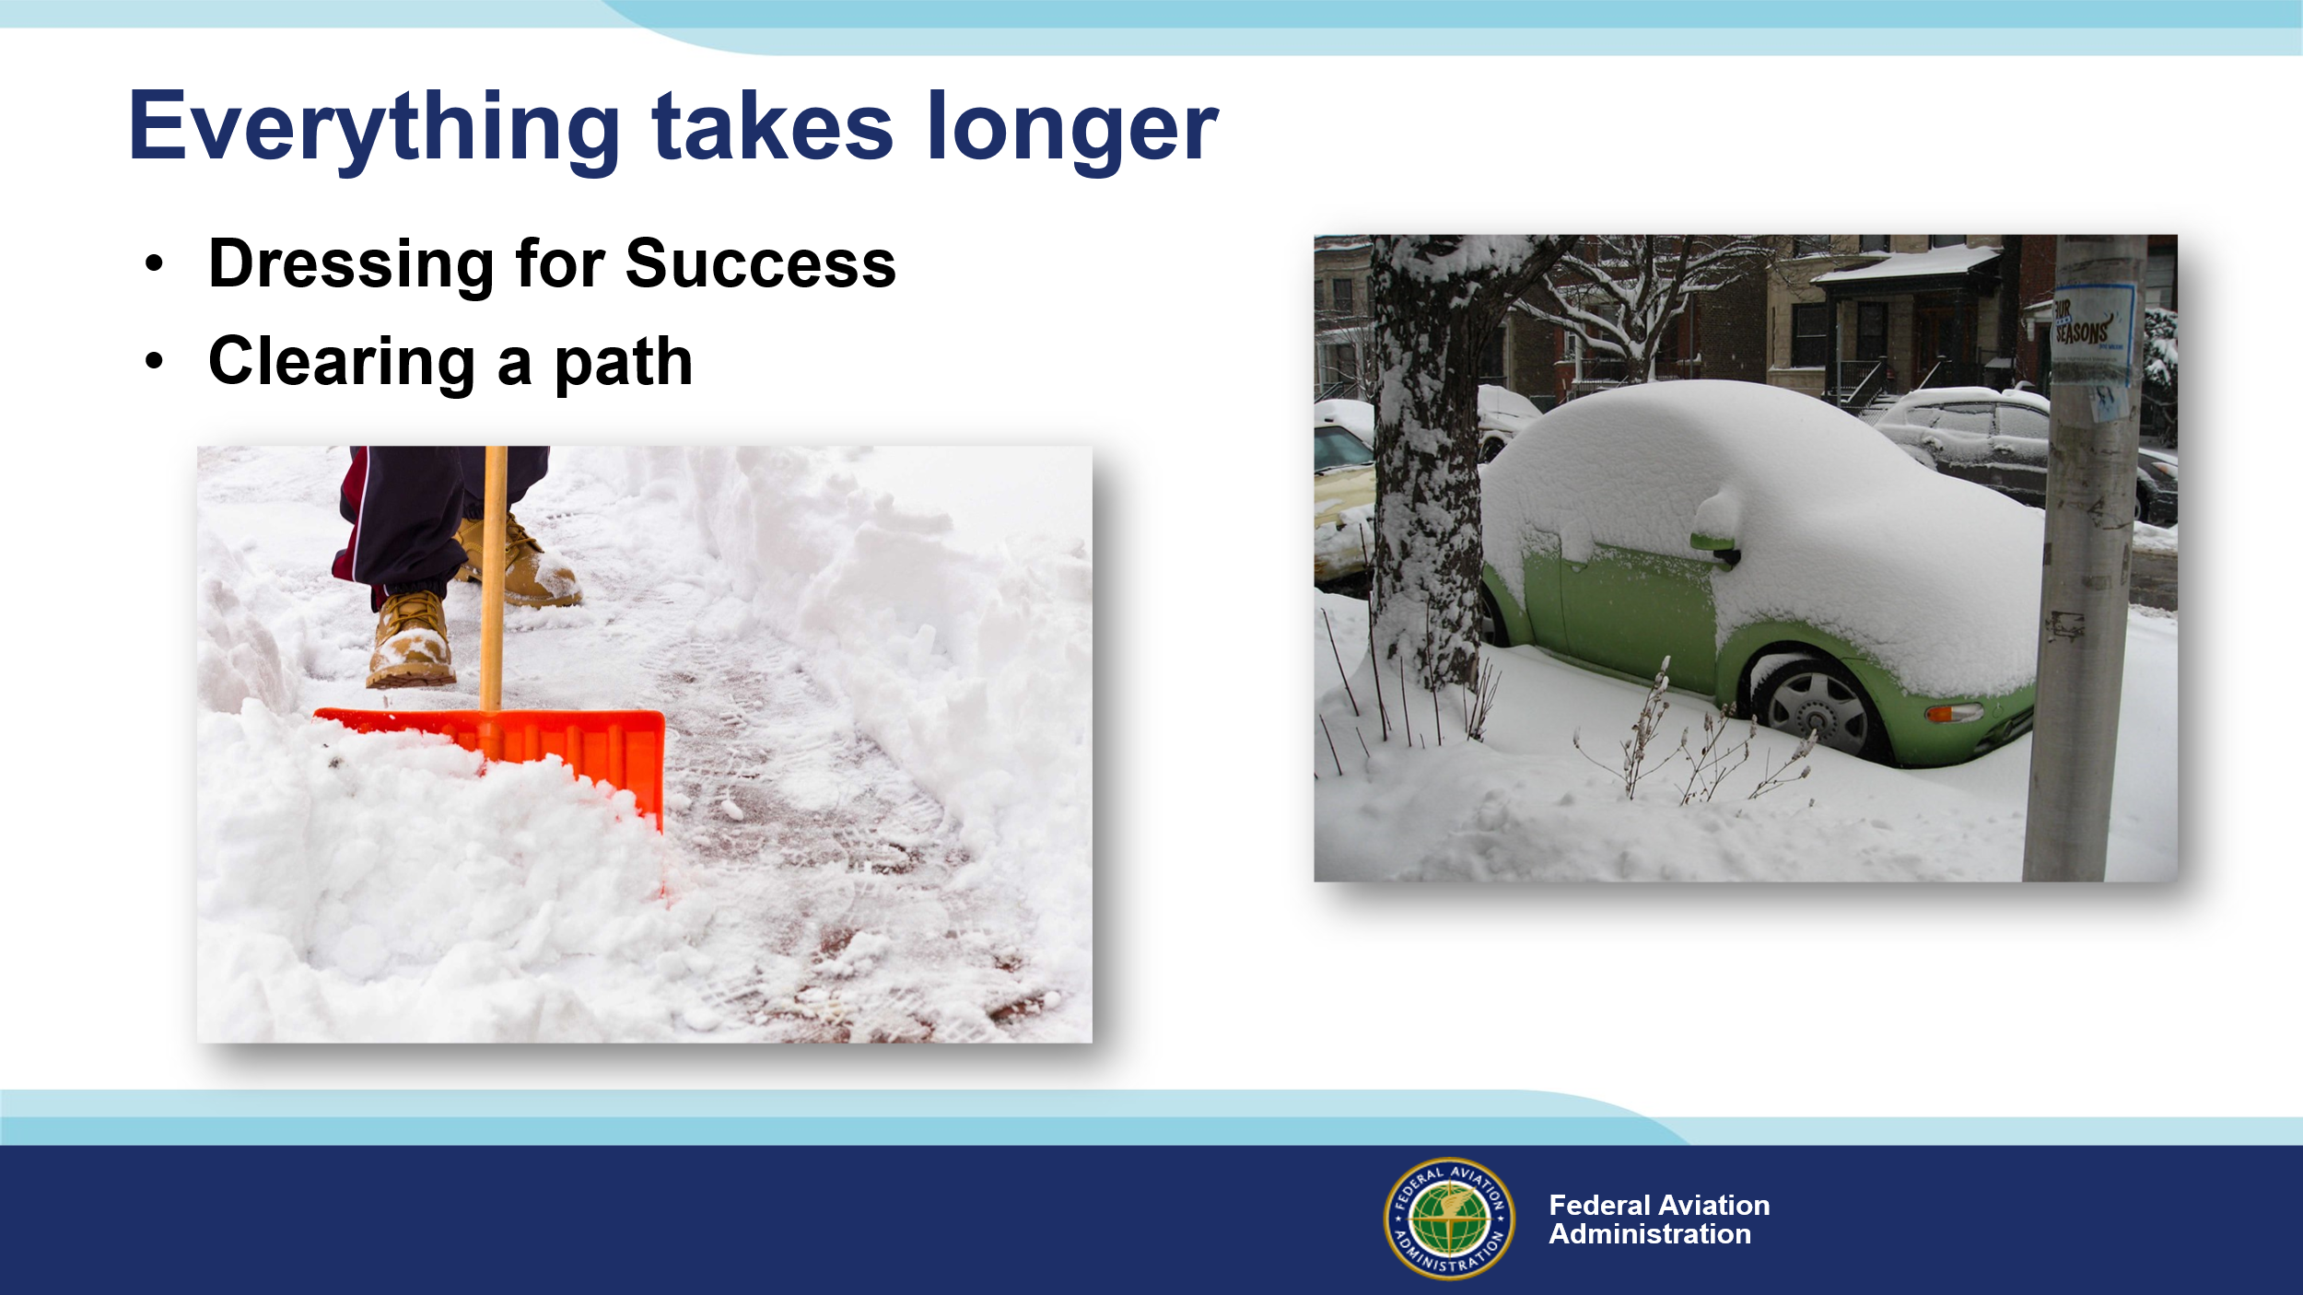 | Slide 4  Leaving the house may involve clearing a path to the car. If you do have to shovel, you’ll also have to clean snow and ice from the car before you start for the airport.  (Next Slide)
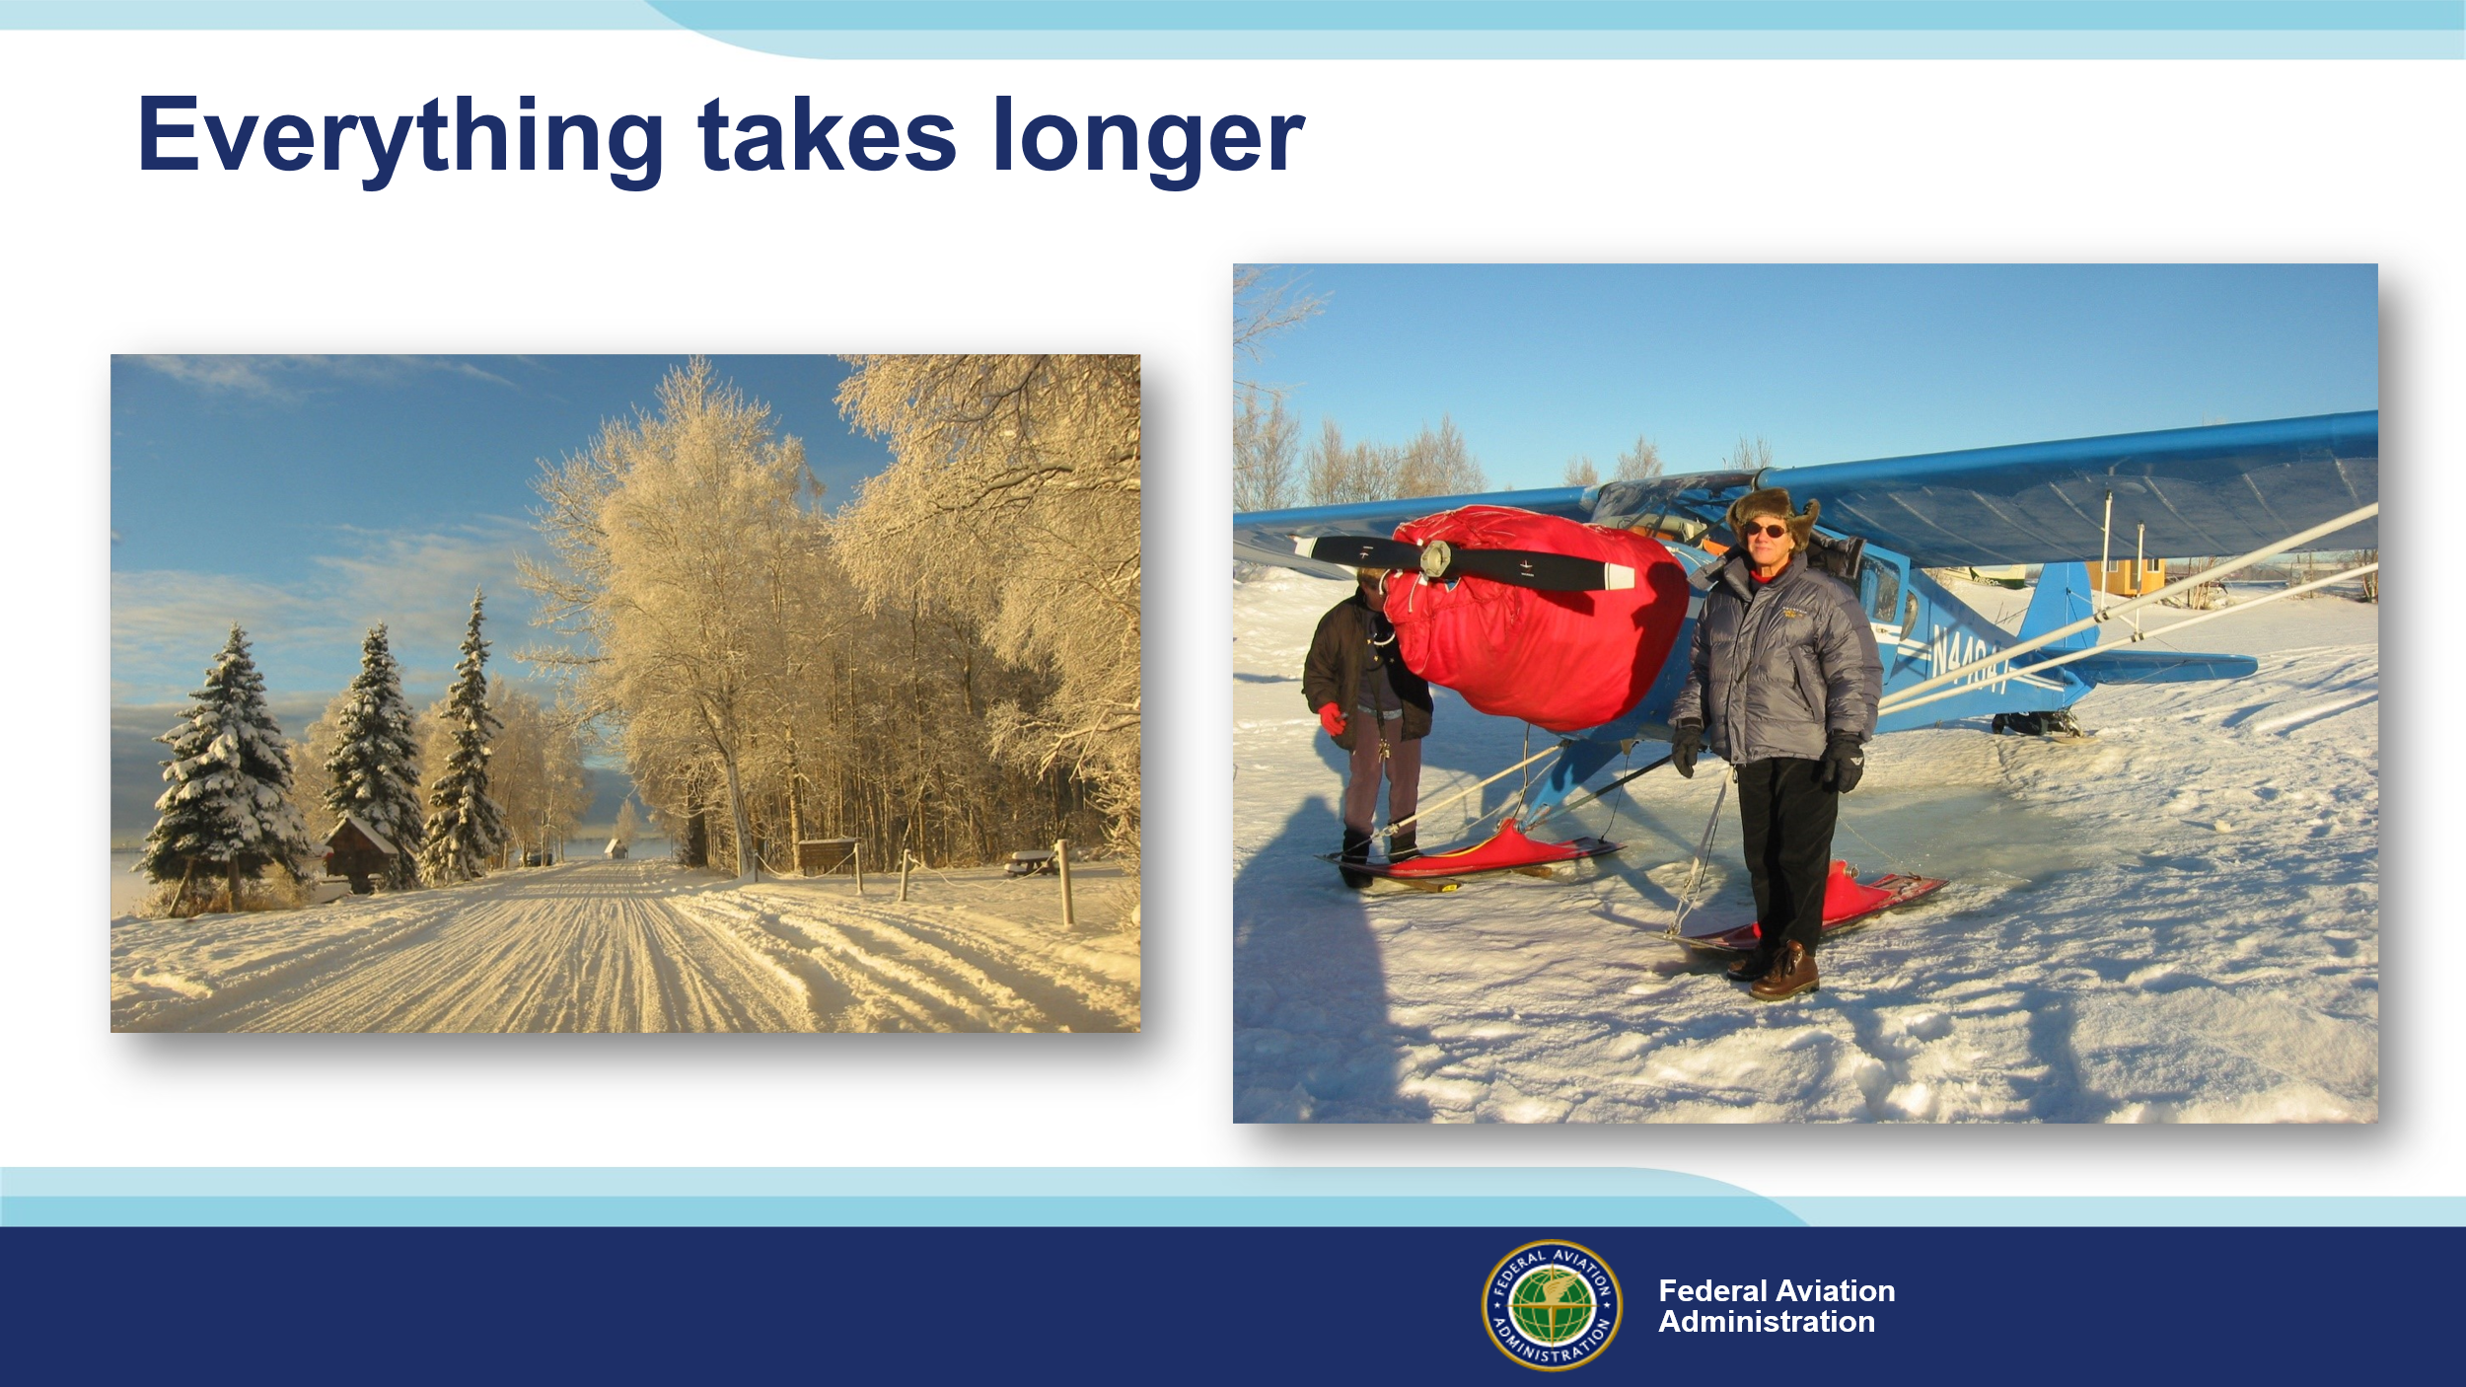 | Slide 5  That trip to the airport can take much longer in winter so add some extra time in your schedule for the commute. (Click)  And, if your aircraft isn’t hangered, you’ll have to allow extra time for preflight activities.  (Next Slide)
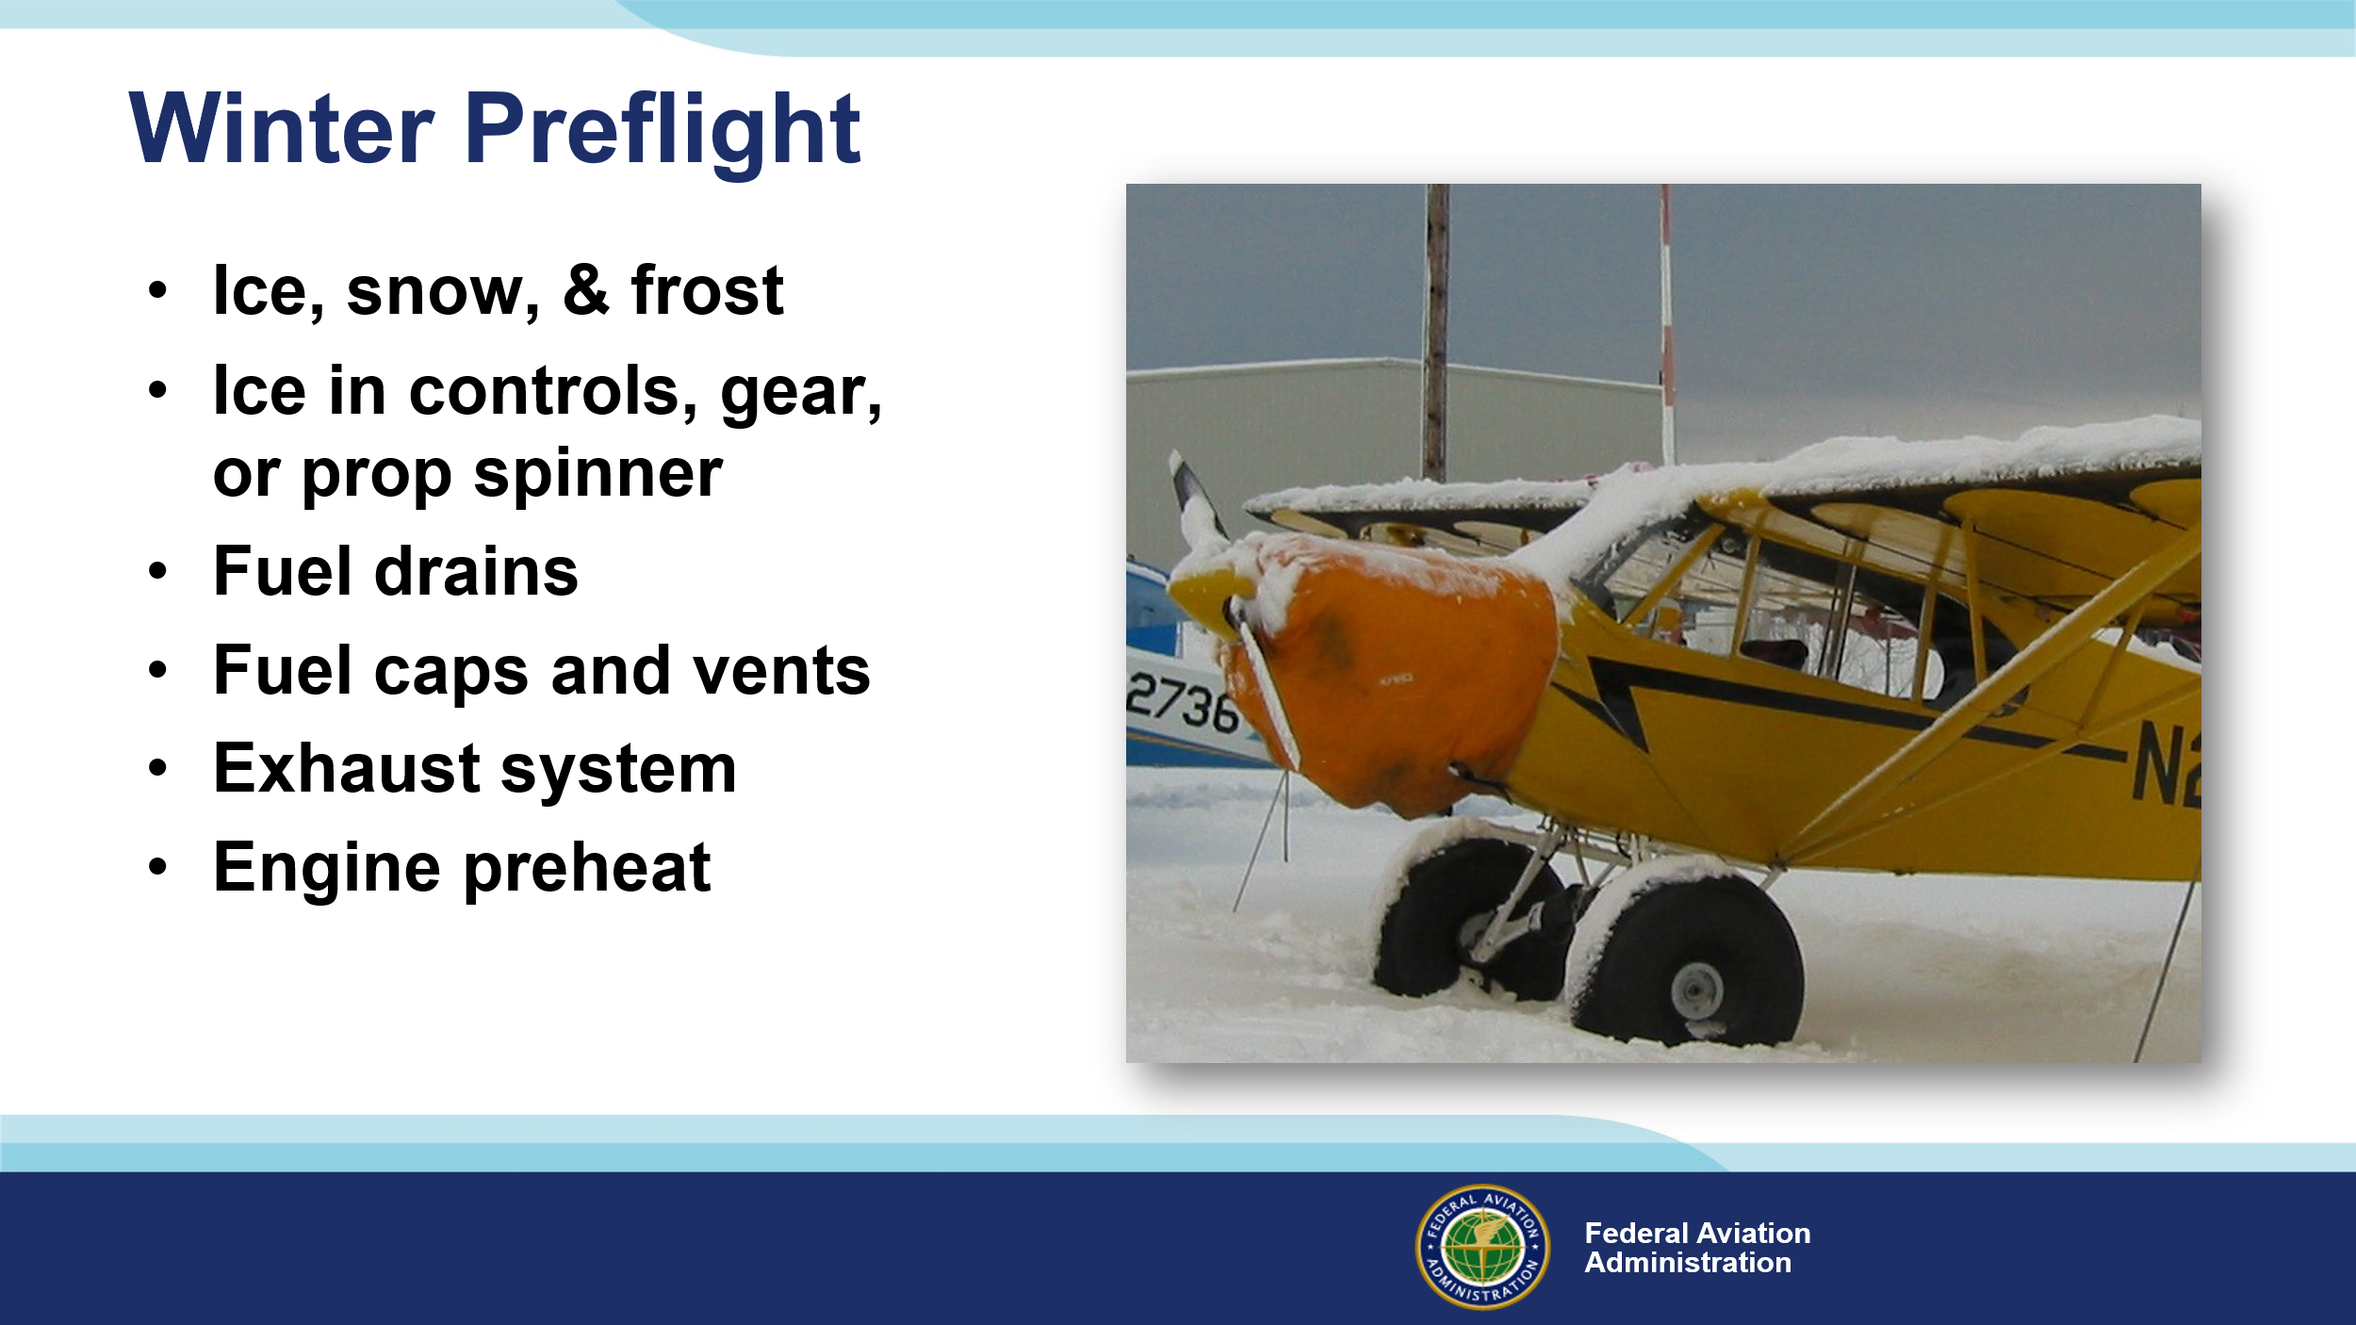 | Slide 6  You’ll need to make sure that the aircraft is ice, snow, and frost free of course. Be sure to check all control surfaces for freedom of movement. Sometimes water can freeze in control linkages, landing gear, and brakes – even in prop spinners.  If you can’t collect a fuel sample, it may mean that water in your fuel tank has frozen in and around the fuel drain. You’ll want to be sure that fuel is free to flow and that tank cap seals are serviceable, and vents are unobstructed.  Exhaust system integrity is essential any time of year but especially in winter when cabin heat is used. A carbon monoxide detector is a good investment in safety.  And you may need to preheat the engine before starting. Follow your engine manufacturers recommendations and, even if preheating is not required, allow plenty of time for the engine to come to operating temperature.  (Next Slide)
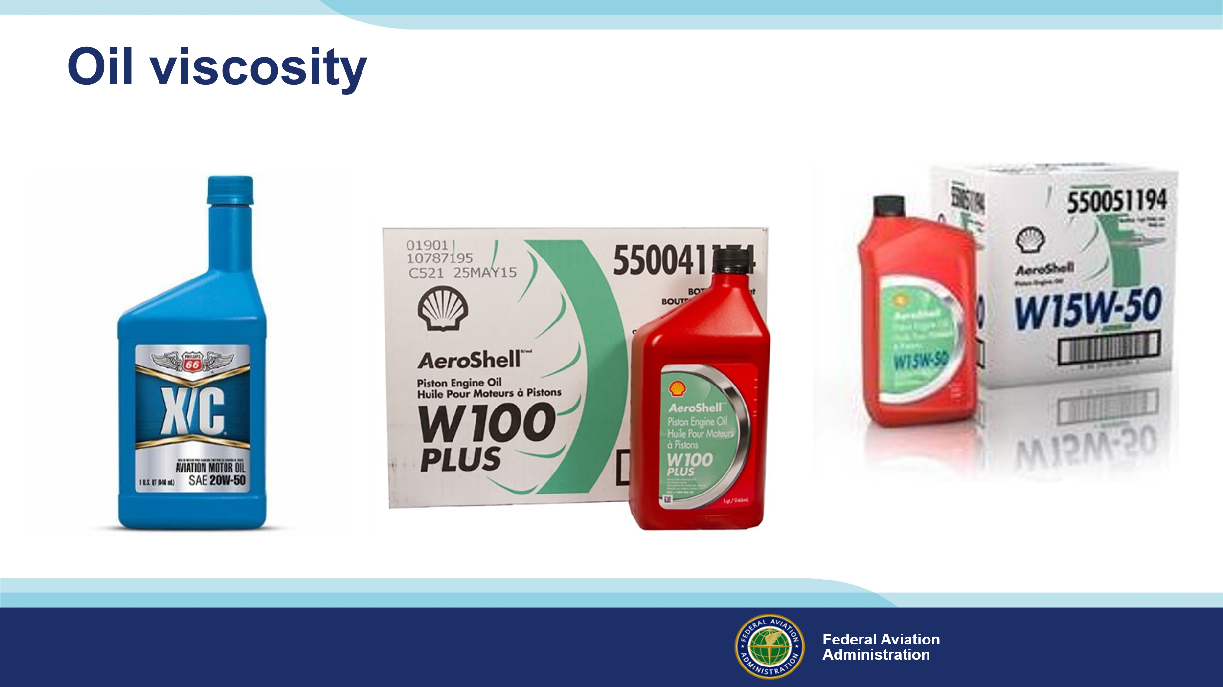 | Slide 7  Be sure to follow manufacturer’s guidance for aircraft oil. Multi-viscosity oils are formulated for a wide range of temperatures. Single viscosity oils should be appropriate for the operational environment temperature.  So, use the appropriate oil for environmental conditions, hangar or preheat your engine for easier starting, and allow extra time to reach operating temperature. Speaking of extra time. You’ll need more time to taxi on snow or worse, ice-covered, taxiways and runways.  (Next Slide)
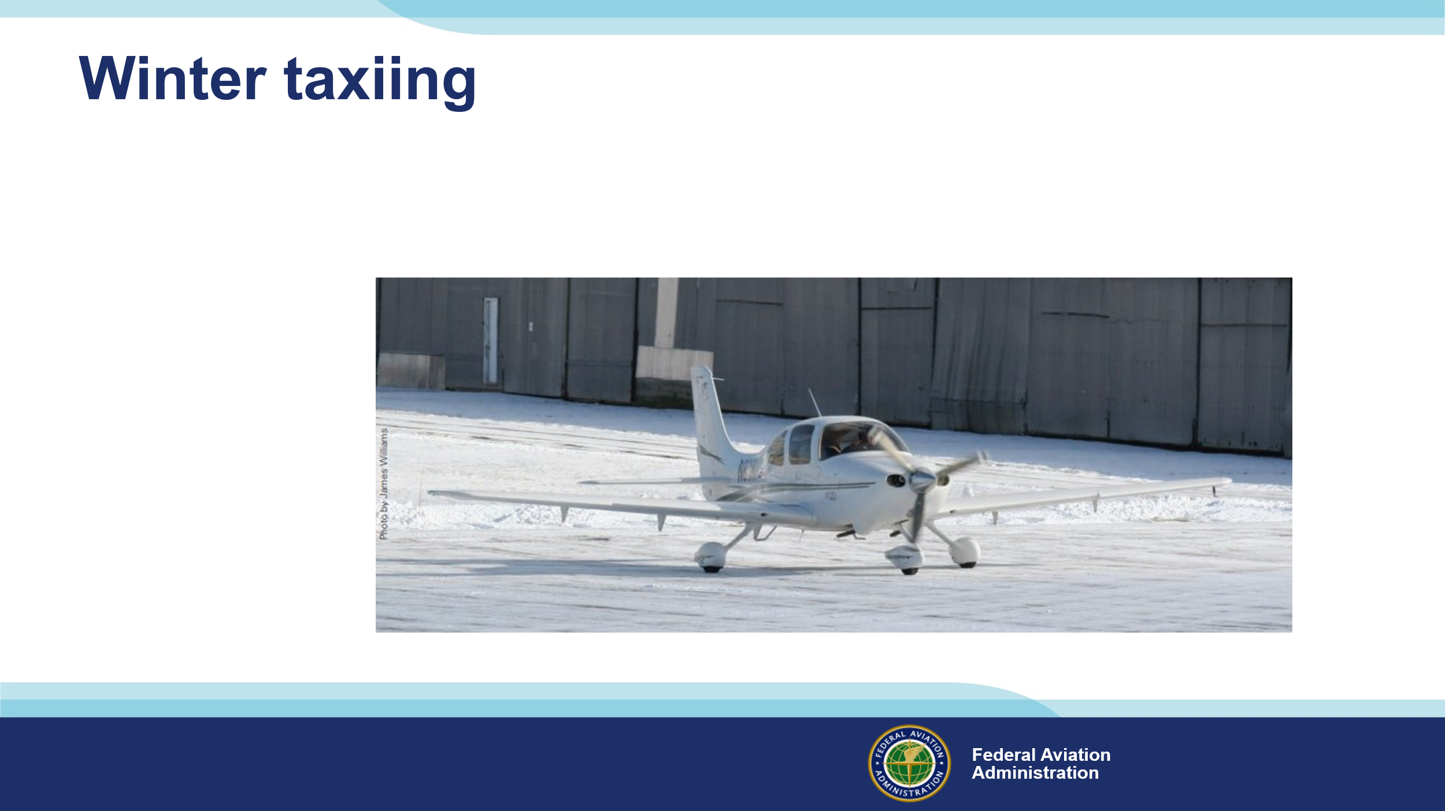 | Slide 8  Taxiing in winter can be exciting. Since your landing gear wheels aren’t driven, you’ll be able to go all right but, stopping and maneuvering in snow or on ice– especially in wind – can be challenging. The rule here is, take it slow – much slower than taxiing on uncontaminated surfaces. Plan turns and stops well in advance and be prepared for loss of traction. Once the flight controls are effective, winter takeoffs are straight forward but beware. Rejected takeoffs and landings on slippery surfaces can require a lot of runway.  (Next Slide)
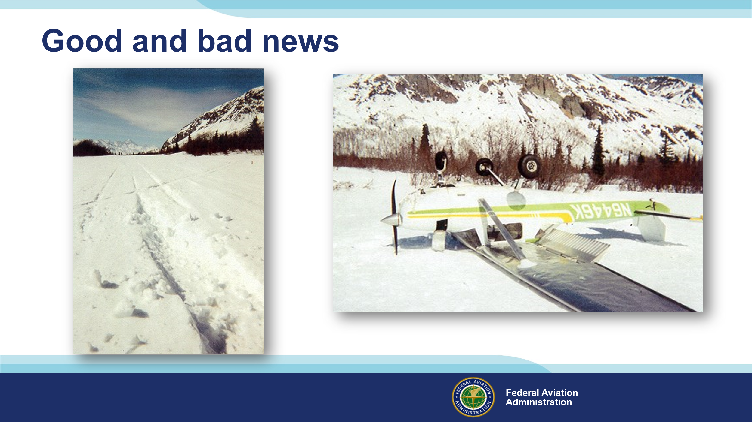 | Slide 9  Although we should be prepared for off airport emergency landings on any flight there are some considerations and preparations that we should all be making when flying in winter. Here’s some good news. Forced landings in winter are statistically less likely to result in injuries or death. Soft snow can absorb energy and slow deceleration. (Click)  In this case, the snow was deeper than the pilot anticipated, and the aircraft ended up on its back. That’s the bad news. There’s no surefire way to judge snow depth from the air. A couple of inches of soft snow on the runway won’t be a problem but more than that could become expensive. As can be the case with any forced landing, you may not be able to use the airplane again – at least not right away. That means you’ll want to prepare to survive for a while in the most hostile environmental conditions expected along your route. Assuming you have no serious injuries, your first order of priority will be shelter and that begins with what you’re wearing.  (Next Slide)
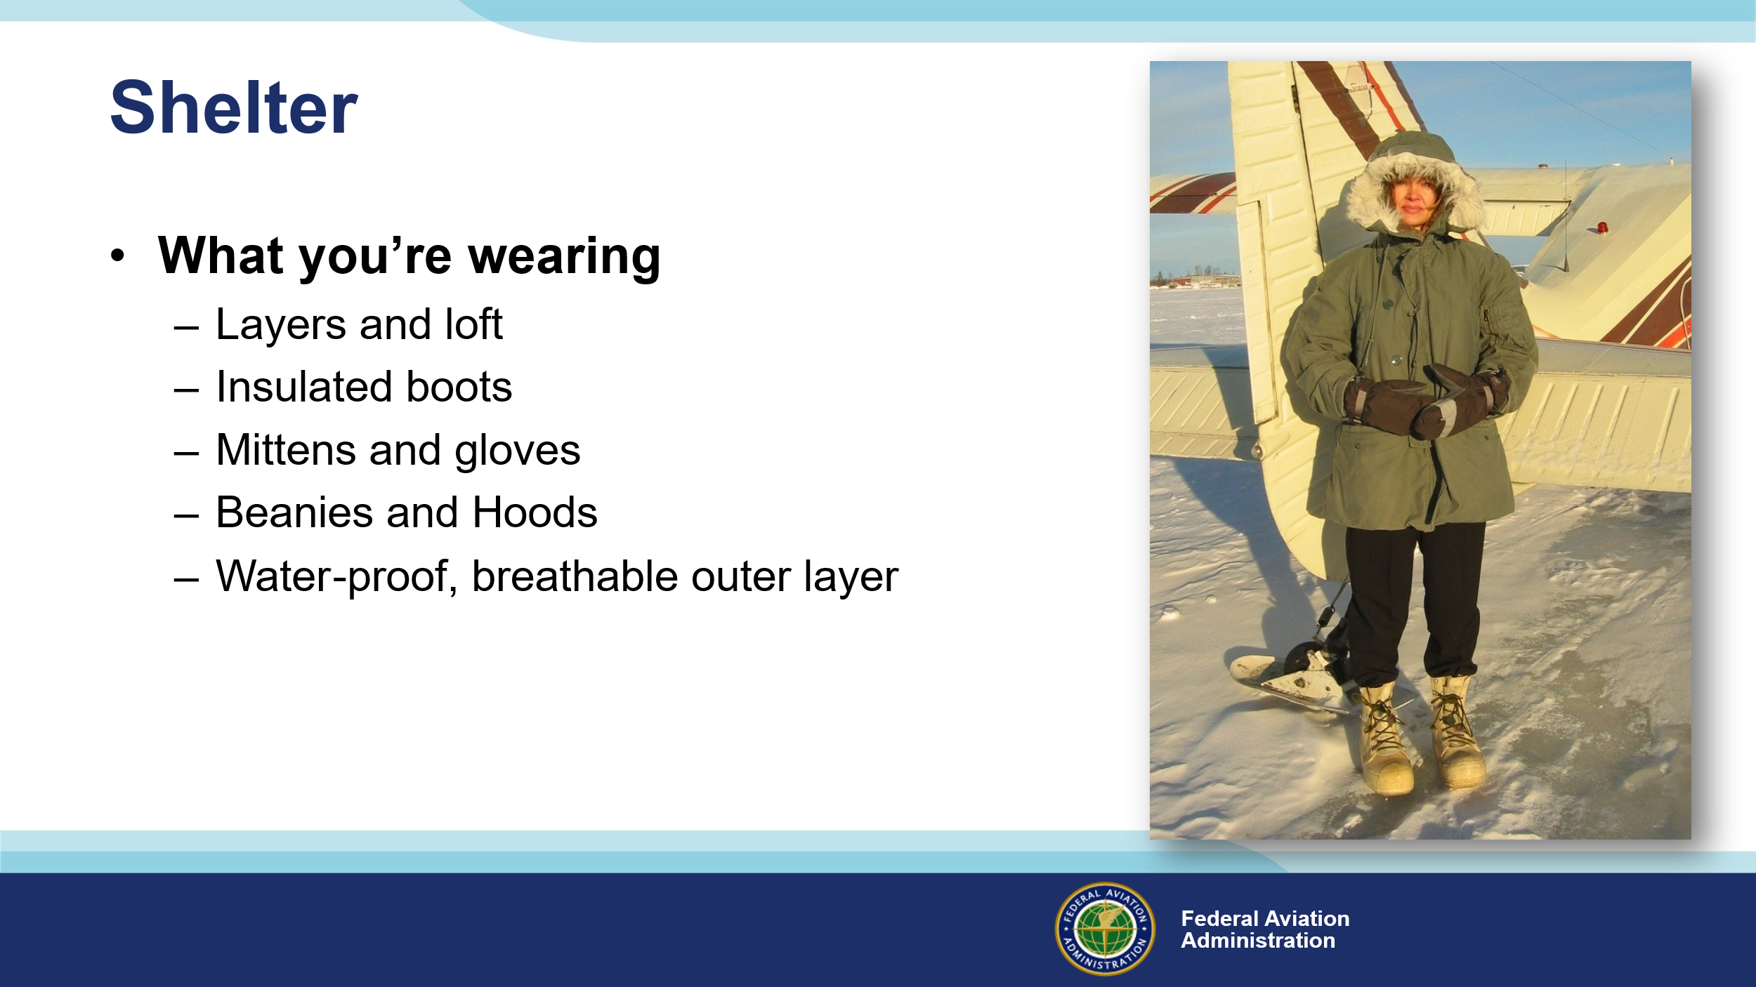 | Slide 10  For best results, dress in layers. Wool is great but synthetics are good too. Insulation creates trapped layers of air that can slow body heat loss. Down is famously good for insulation – that is until it becomes wet. Synthetic fiber insulation is better when it’s soaked. (Click)  Insulated footwear is a must if you’re going to spend much time in the cold. Whether you’re sporting Army surplus bunny boots shown here or something from a reputable outfitter, keeping your feet warm and dry is a must. (Click)  Mittens are warmer and it’s easier to work in gloves. A pair of each is a good idea. Keep them in a parka pocket until needed. (Click)  A wool or synthetic fleece beanie is great for a base layer, but a hood is also a must have. It can be attached to your outer layer parka. (Click)  Pilots can choose from a wide variety of waterproof breathable outer layer garments. Snow pants fit over your base layer and a parka with plenty of  pockets completes the outfit.  (Next Slide)
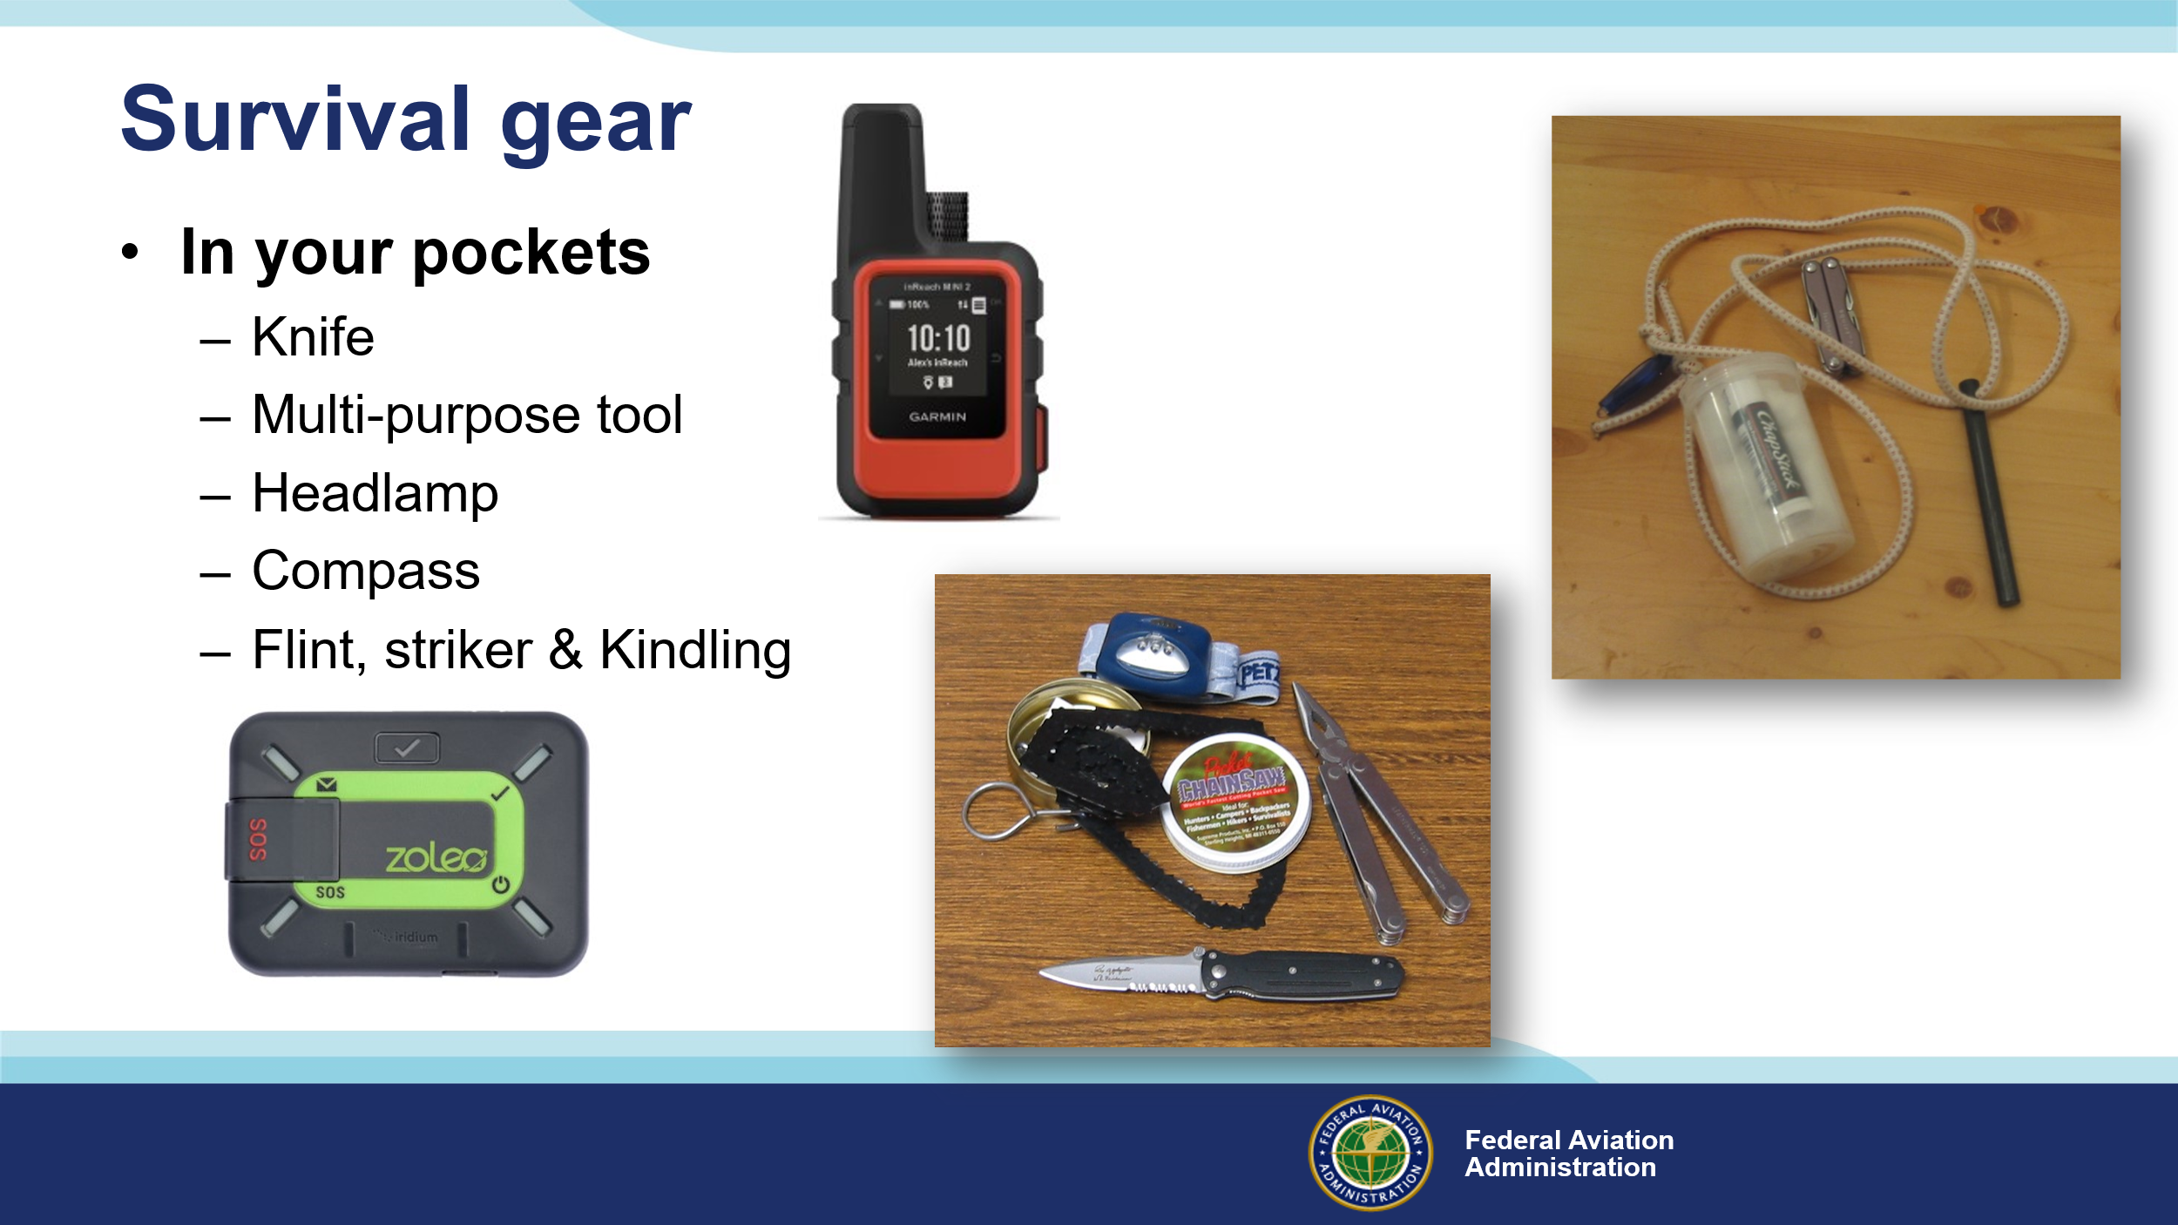 | Slide 11  So why is it important to carry survival gear in your pockets?  Presentation note: Pause here for audience discussion of the question or proceed to answer it yourself.  There’s an old saying that suggests it’s reasonable to assume that, provided you’re un-injured, you’ll exit a downed aircraft with what you’re wearing and what’s in your pockets. Any other supplies may or may not be reachable. So, with that in mind, survival gear for your pockets should include a sturdy pocket or sheath knife and, or a multi-purpose tool with a knife blade. Include a headlamp, and a compass – stored in a separate pocket free of magnetic objects. In this picture we also see a compact chain saw that can be useful in preparing wood for a fire. (Click)  And speaking of fire, Here’s a compact incendiary essentials kit consisting of a flint and striker or waterproof matches and a waterproof container of kindling – in this case cotton balls - and a source of wax. Apply lip balm to a cotton ball and you have an excellent fire starter. (Click)  Most of us carry cell phones these days. They’re great for everyday communicating but not much use in remote areas. That’s why many pilots are carrying personal locater and communication devices. They’re relatively inexpensive and they’re an effective way to keep in touch from the boonies.  (Next Slide)
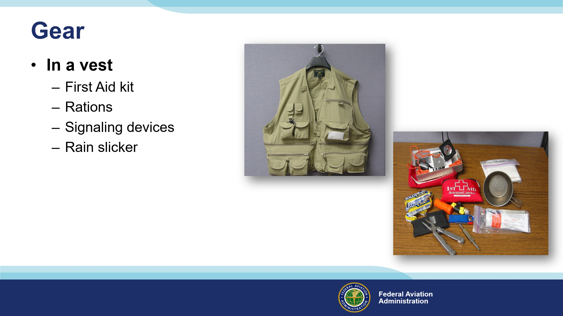 | Slide 12  It’s common for bush pilots to wear a survival vest while flying. A vest can store your survival gear in dedicated pockets. You can carry more than you can stuff in your pockets, and you don’t have to repack for each trip. Just replace what you use and things that have a shelf life such as batteries and food. (Click)  In this example we have the things we mentioned earlier plus a first aid kit, some survival rations, a couple of signaling devices, a rain slicker, titanium cup, and even some toilet tissue. The small pieces fit into an aluminum box that’s waterproof. Both the box and cup can be used for wilderness cooking.  (Next Slide)
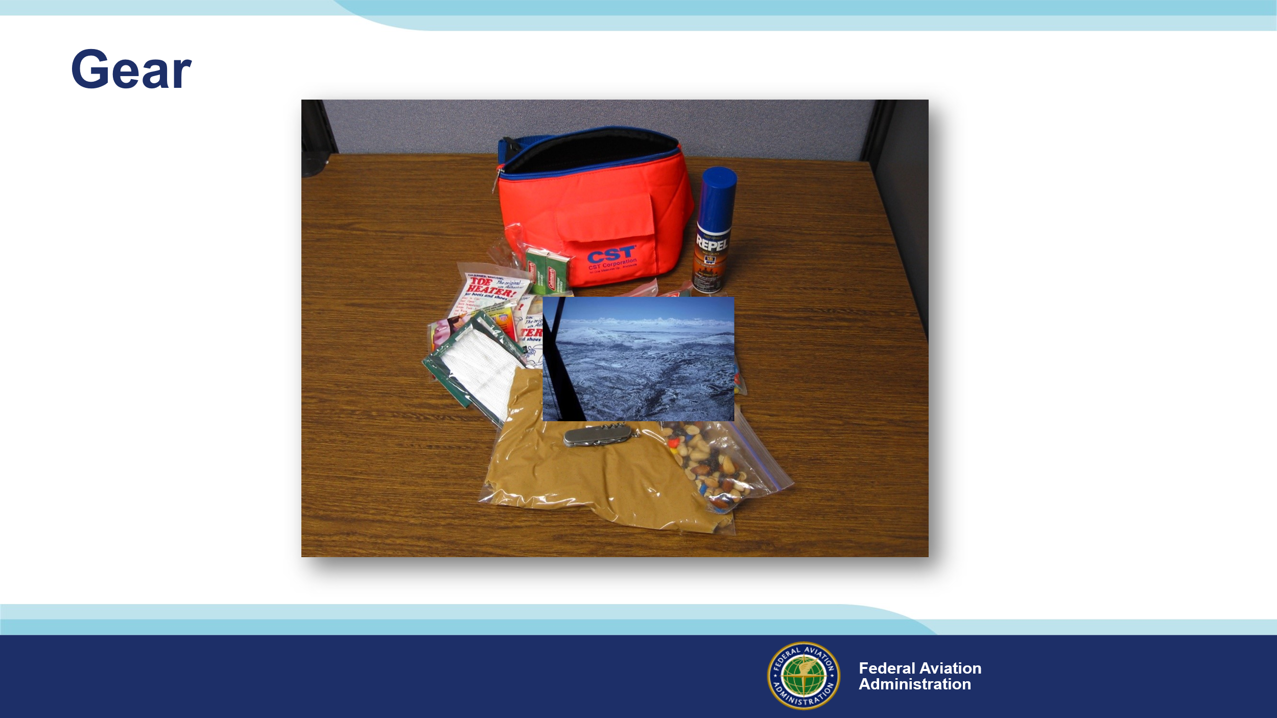 | Slide 13  One Alaskan aviator carries this fanny pack with even more survival gear. Note the gallon bag of peanut butter – an excellent survival food.  So, we’ve done a detailed preflight and we have our survival gear. Are we good to launch? Maybe so but first let’s talk about our route of flight.  (Next Slide)
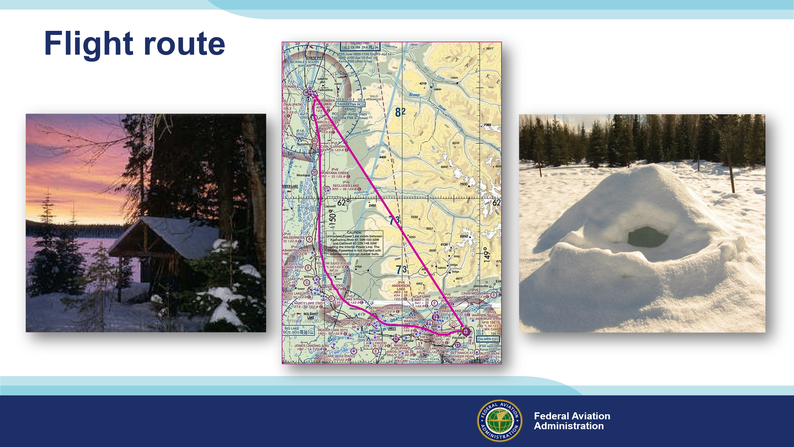 | Slide 14  When it comes to winter flying, the direct route isn’t always best. (Click)  Following a highway or railroad may take a little longer but, if you have to land off airport, you’ll be closer to civilization and folks who can help. Winter days are short and unless you’re close to habitation, you’ll likely have to spend at least one night in the field. (Click)  Your route selection may well determine whether you spend the night in accommodations like this. (Click)  Or something more primitive that you build yourself like this snow cave. You can survive there but you will be far from comfortable. By the way – if temperatures are below freezing and especially if it’s windy, a snow cave is preferable to spending the night in your aircraft. You need lots of insulation and a small space for your body to heat. Perhaps it would be a good idea to pack a tent and some sleeping bags.  (Next Slide)
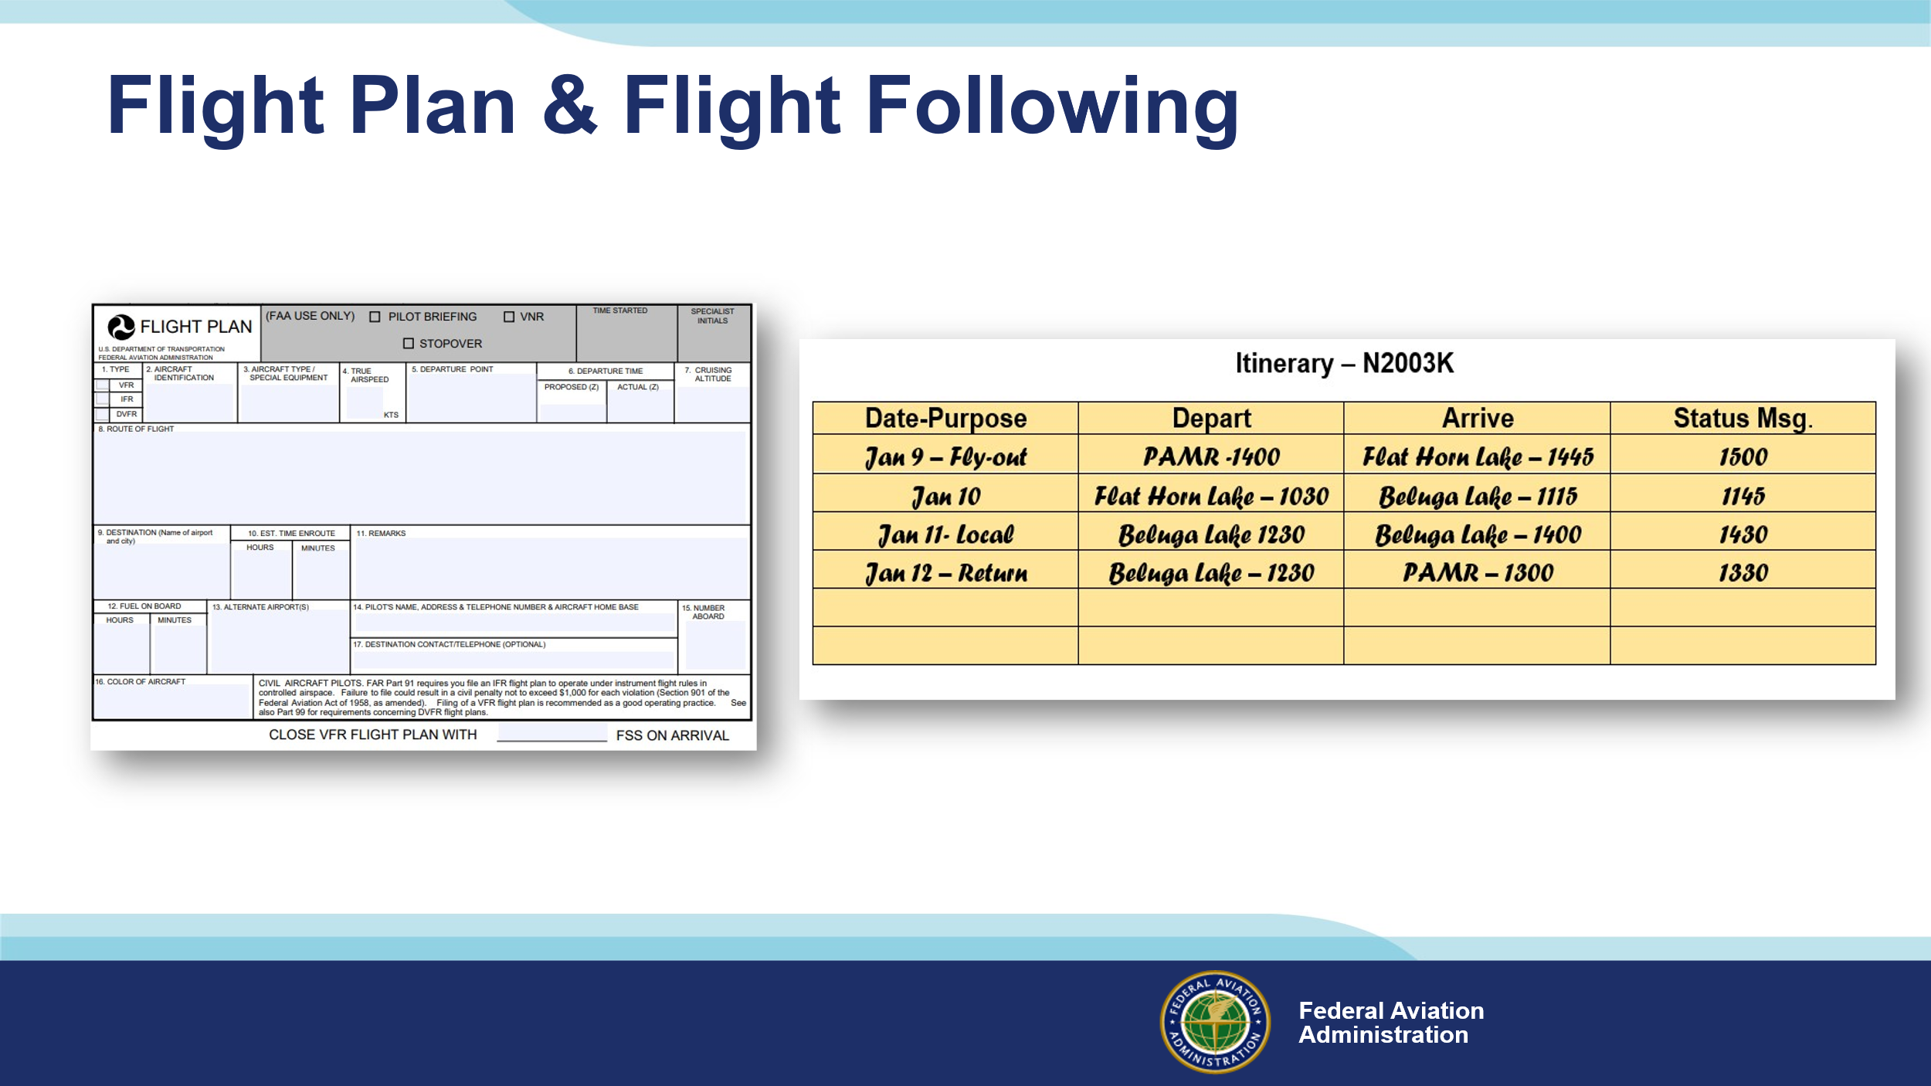 | Slide 15  Obviously, you’ll want to file a flight plan for any flight and requesting flight following makes sense too. But especially if you’re going on a multi-day trip to areas where communication may be a challenge, you may also want to file an itinerary with a trusted agent before you leave. If you’re equipped with a Satellite Phone, or even a Satellite Messaging Device, you can transmit periodic status reports to your agent. A missing status report could trigger and target search and rescue efforts even if no flying was planned for the day.  (Next Slide)
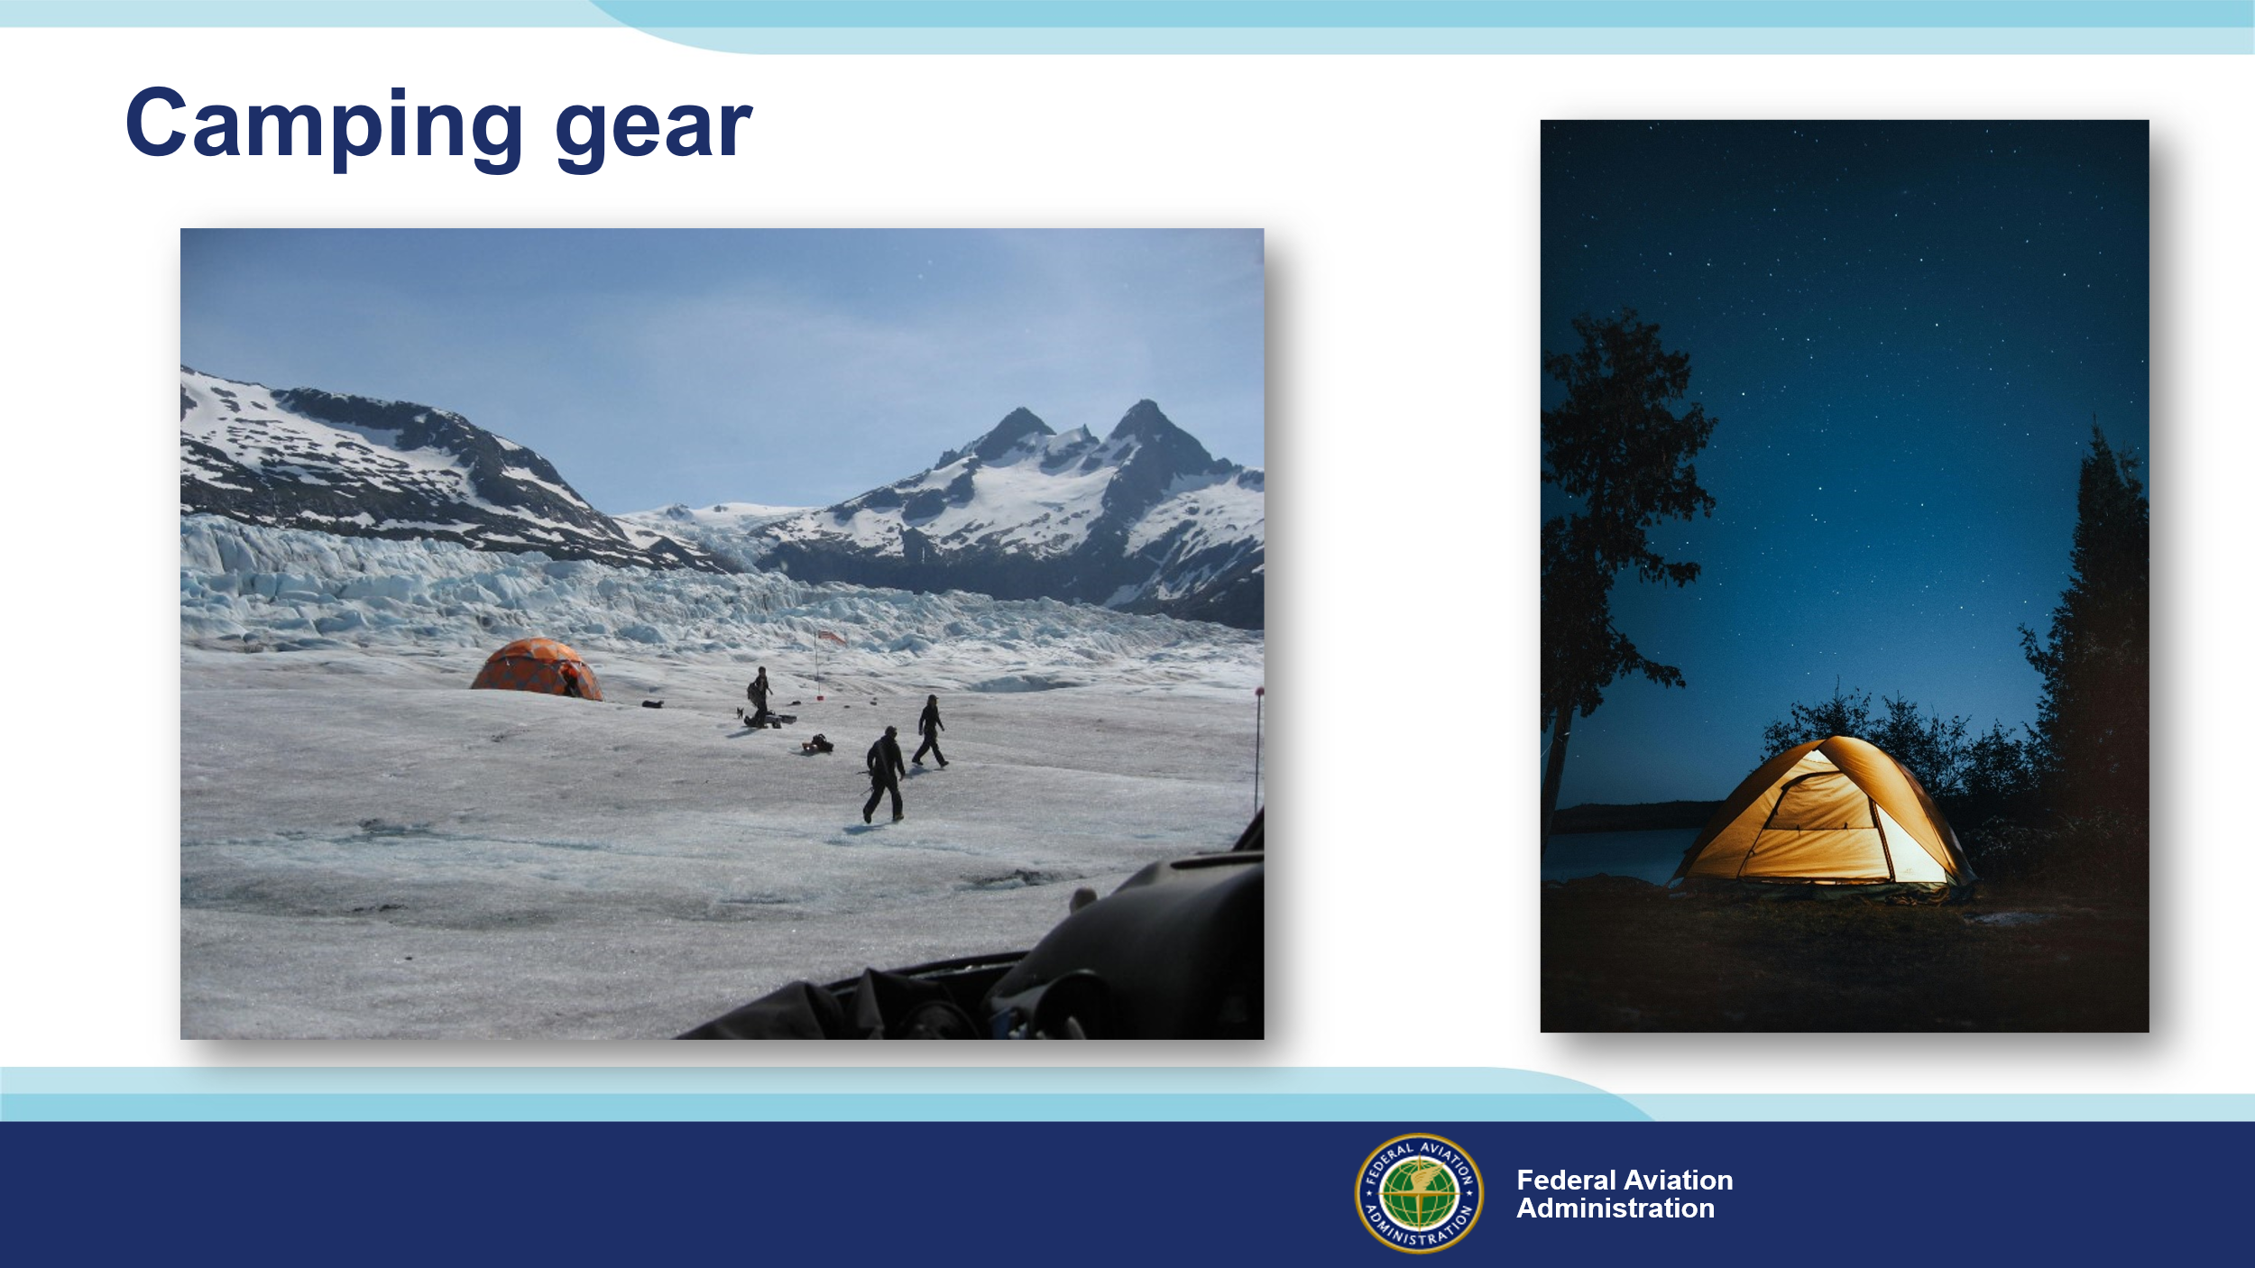 | Slide 16  You can survive quite comfortably in winter if you have the appropriate gear, and you know how to use it. That said, you’ll have to stow camping equipment in baggage compartments that may not be accessible if there’s a fire or the aircraft ends up in the water. That’s why we advise you to dress for the environment and have basic survival items on your person.  (Next Slide)
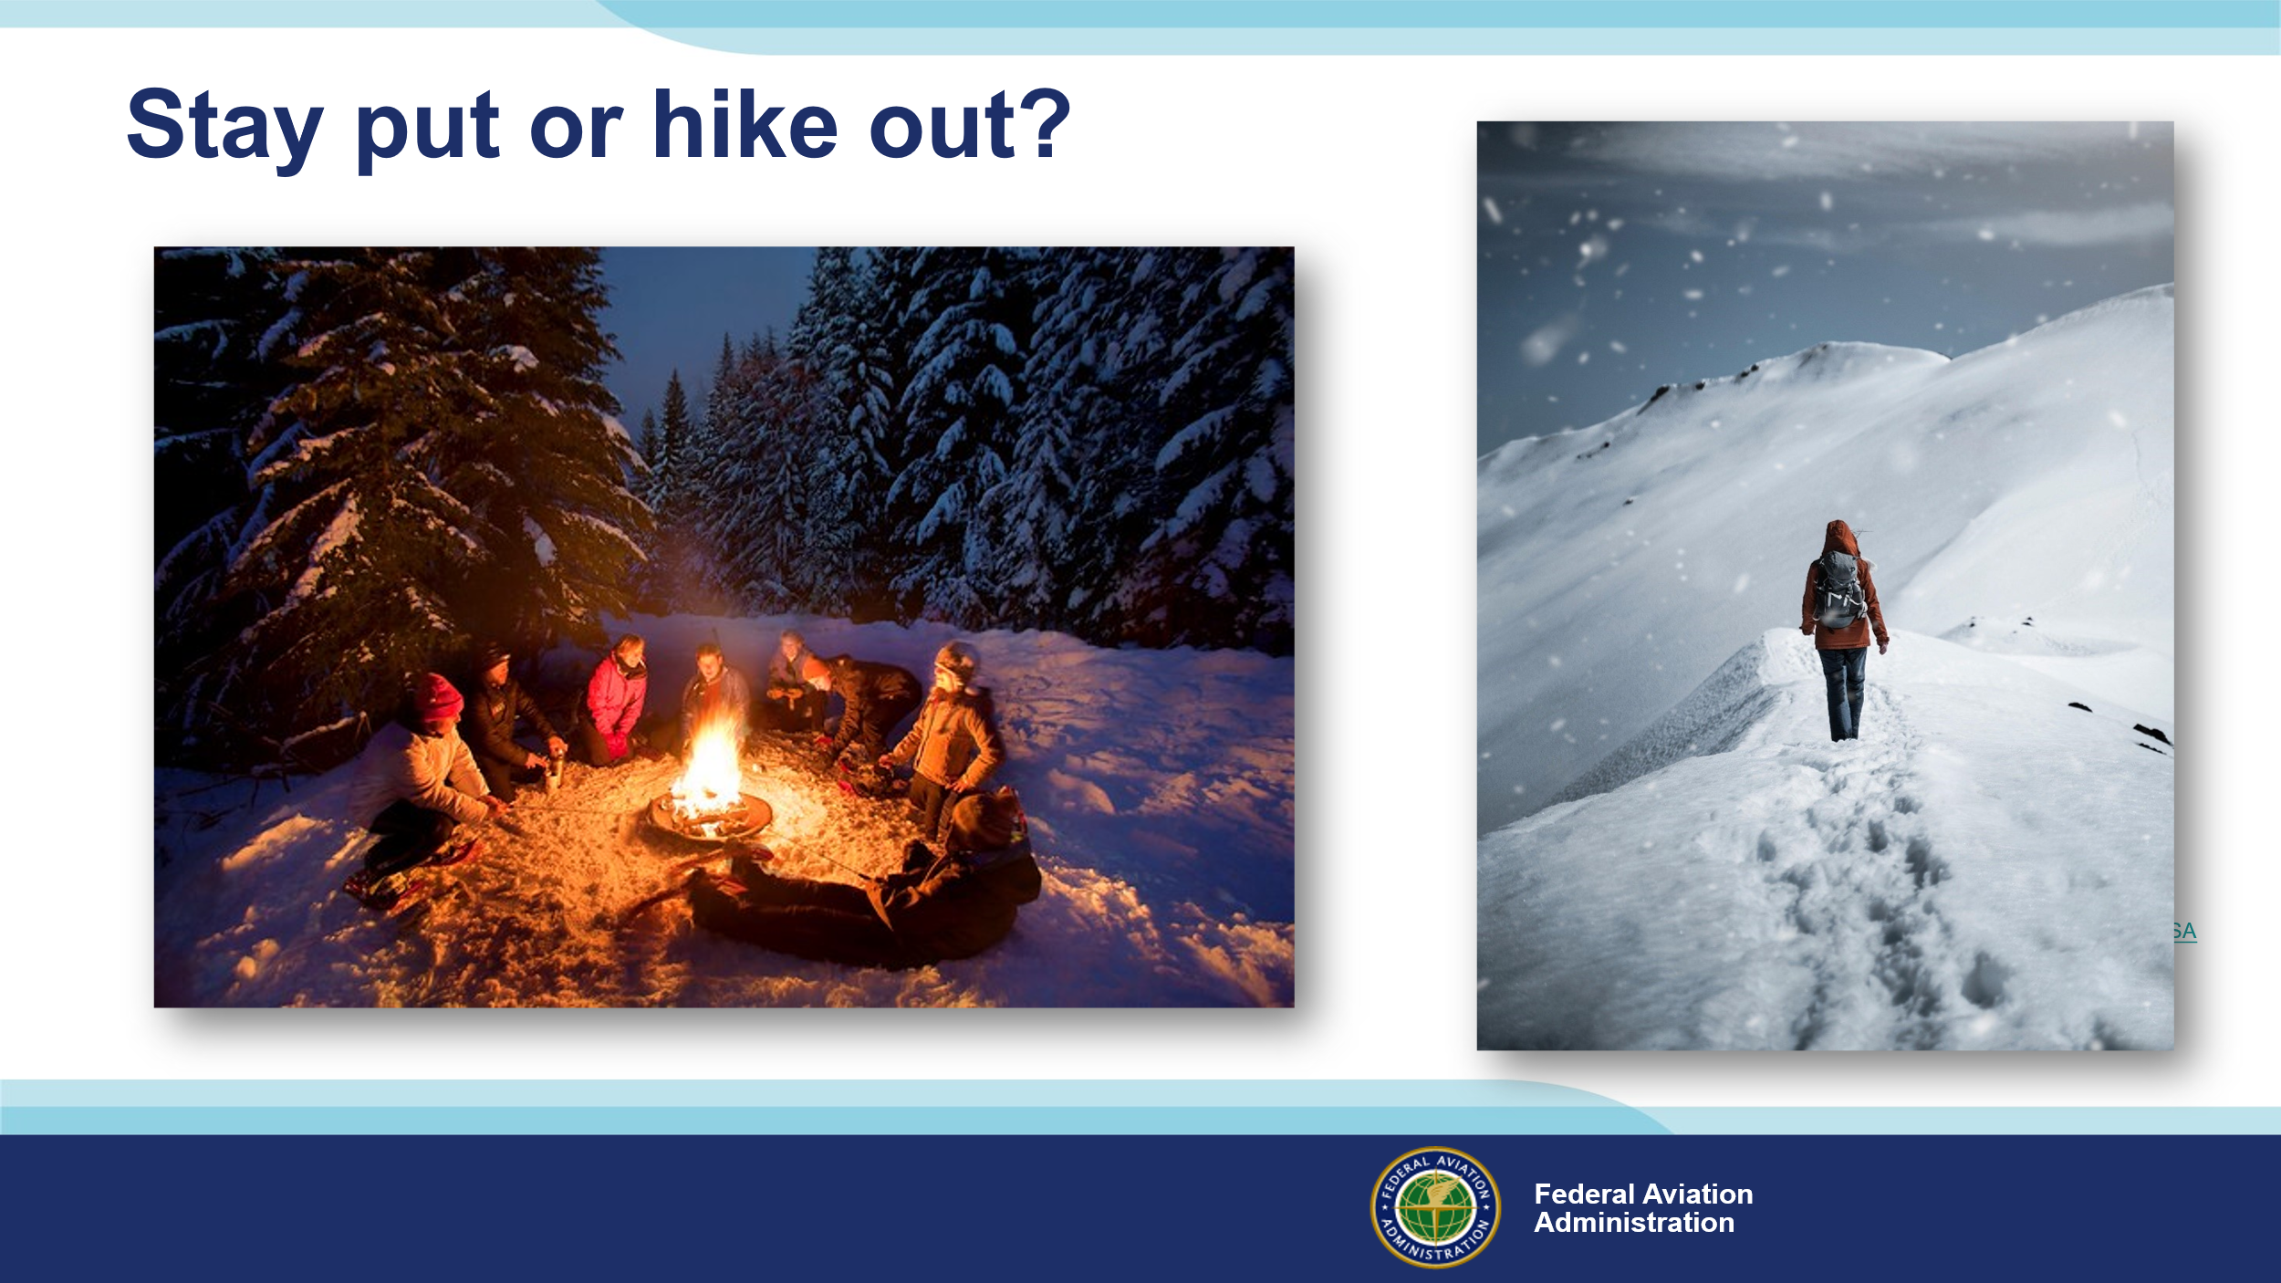 | Slide 17  You can keep your skills sharp between flights by With proper knowledge, equipment, and most importantly, the will to survive; you can spend several winter days relatively comfortably in the field. If you’ve filed a flight plan and you’re on the filed route, folks will be looking for you and, if you’re camped near your aircraft, it will be easier for searchers to spot you. There are many arguments for staying put rather than hiking out. You’ll expend much more energy hiking through snow than you will sitting by a fire and, if you’re communicating with a trusted agent, rescuers are sure to be on their way.  (Next Slide)
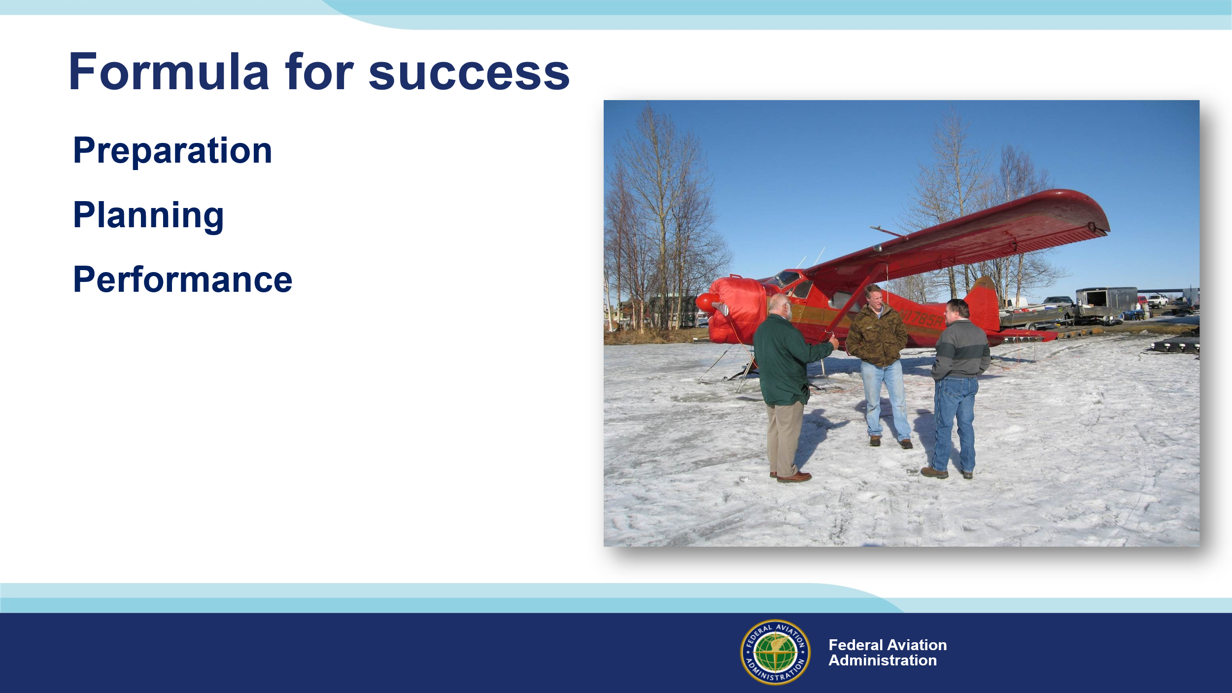 | Slide 18  Success in any flying endeavor is ensured by proper preparation of pilot, passengers, and aircraft. Participation in a formal pilot proficiency program will enable you to fly at the top of your game and, just as importantly, help you to avoid situations that might require you to operate beyond your capabilities. Aircraft preparation includes mechanical condition of course but also maintenance and inspection intervals, weight and balance, and performance calculations. Likewise, passengers should be prepared for the flight environment and for survival in the environment over which you’re flying. (Click)  Planning optimal routes and participation in flight following are obvious best practices - also matching of destinations to aircraft and pilot performance capabilities. Leaving an itinerary with a trusted agent and periodic check in calls are also recommended. (Click)  Finally – performing within the plan parameters. That’s often expressed as, “plan the flight and fly the plan.” Good advice for most circumstances but pilots should constantly assess whether the flight is going to plan. If it isn’t, it’s essential to recognize that fact and immediately work to return to plan or pursue an alternate, safer course of action.  (Next Slide)
 | Slide 19  Human Factors knowledge is showing us how to excel in dealing with the physical, intellectual, and emotional challenges of flight. The benefits of Human Factors study are so great that we’ve developed a series of online Human Factors for Pilots courses. We encourage you to explore the series. Navigate to the URL or scan the QR code on screen for a FAASTeam Human Factors course catalog that features direct links to each of the courses.  (Next Slide)
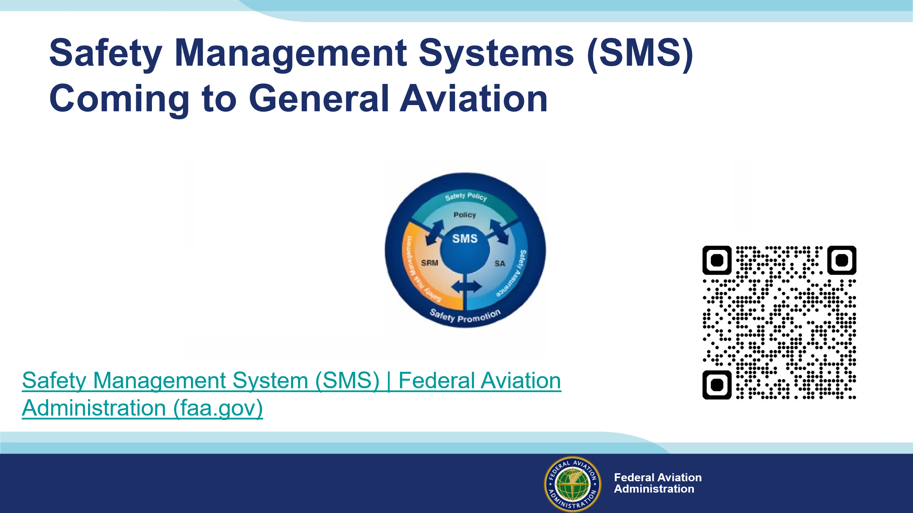 | Slide 20  Safety Management Systems are a set of policies and processes that can increase the safety and efficiency of any flight operation. And FAA is bringing SMS to General Aviation. You may have heard of SMS but thought it was only for large organizations but actually, SMS can be scaled to fit any operation large or small.  There are 4 major components to a Safety Management System (Click)  Safety Policy – a documented commitment to safety that runs from the head of an organization to its newest member. (Click)  Safety Risk Management – a process that identifies hazards within an operation, determines to what extent an identified hazard may impact flight safety, and controls the risk of occurrence to an acceptable level. (Click)  Safety Assurance – By collecting and analyzing information derived from safety performance data Safety Assurance ensures the performance and effectiveness of Safety Risk Controls. (Click)  Safety Promotion communicates safety information and commitment throughout the organization. (Click)  You can find more information about Safety Management Systems at the URL on the Screen.  (Next Slide)
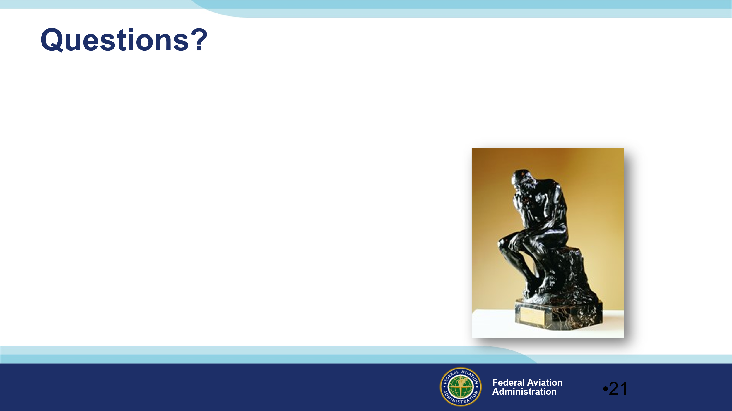 | Slide 21  Presentation Instruction: You may wish to provide your contact information and main FSDO phone number here. Modify with  Your information or leave blank.  (Next Slide)
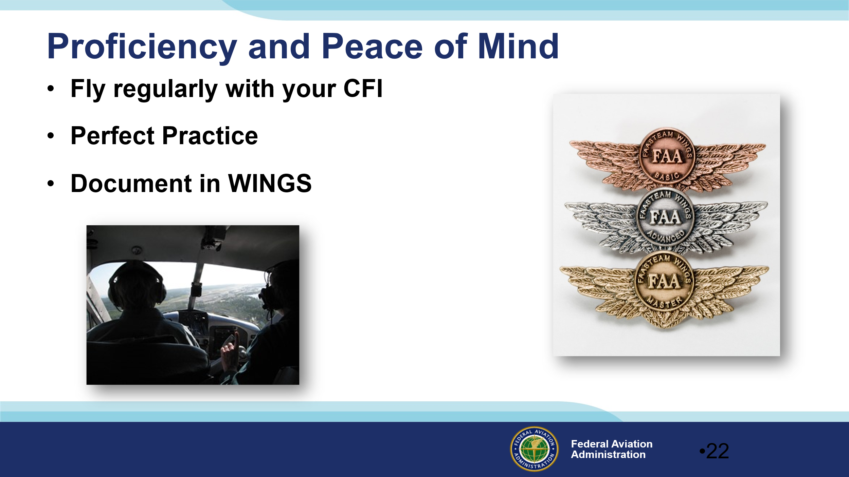 | Slide 22  There’s nothing like the feeling you get when you know you’re playing your A game and in order to do that you need a good coach (Click)  So, fly regularly with a CFI who will challenge you to review what you know, explore new horizons, and to always do your best. Of course you’ll  have to dedicate time and money to your proficiency program but it’s well worth it for the peace of mind that comes with confidence. (Click)  Vince Lombardi, the famous football coach said, “Practice does not make perfect. Only perfect practice makes perfect.” For pilots that means  flying with precision. On course, on altitude, on speed all the time. (Click)  And be sure to document your achievement in the Wings Proficiency Program. It’s a great way to stay on top of your game and keep you flight review current.  (Next Slide)
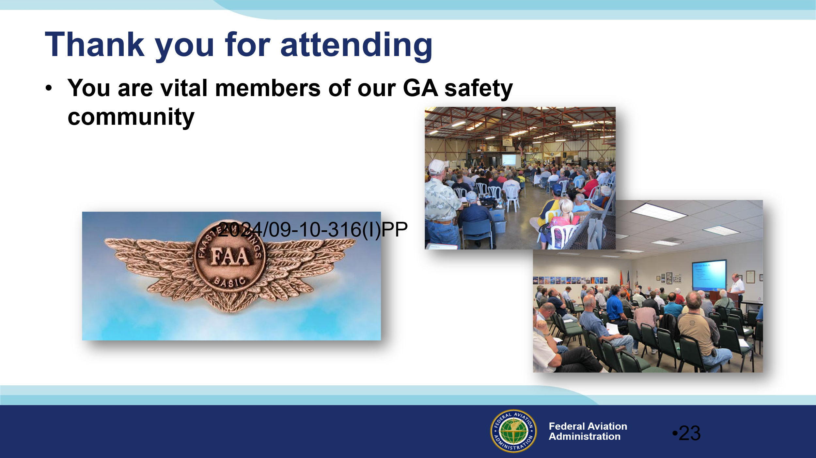 | Slide 23  Your presence here shows that you are vital members of our General Aviation Safety Community. The high standards you keep and the examples you set are a great credit to you and to GA.  Thank you for attending.  (Next Slide)
Slide 24

(The End)

Appendix I – Equipment and Staging
Equipment:
- Projection Screen & Video Projector suitable for expected audience
  - Remote computer/projector control available at lectern or presenter location
    - In lieu of remote – detail a Rep to computer/projector control.
- Presentation Computer
  - Note: It is strongly suggested that the entire program reside on this computer.
- Back up Projector/Computer/Media as available.
- PA system suitable for expected audience
  - Microphones for Moderator and Panel
    - Optional Microphone (s) for audience
- Lectern (optional)
Staging:
- Arrange the projection screen for maximum visibility from the audience.
- Equip with PA microphones
- Place Lectern to one side of screen. This will be used by presenters and moderator.

IMPORTANT – Once you have completed outreach on this topic, please help us track the outreach you have done by entering a SAS record.

